

Website User Guide

Updated August 23, 2013

A Product of doForms Inc.

Table of Contents

Legal Notice 6
Contact Support 6
Video Tutorials 6
Requirements 6
Overview 7
Mobile Data Collection App 7
Data Website 8
doForms Dispatch 8
Security for Paid Accounts 9
This Guide 10
Accessing the doForms Website 11
Requirements 11
doForms Website URL 11
Website Privileges 11
Request Website Access 12
Sign in 13
Sign out 13
Website Home 14
Header Tabs 14
Understanding Forms, Projects & Mobile Units 15
Deploying Forms to Mobile Units 16
Viewing Data 17
Sending Dispatches and Work Orders 17
Important Notices 17
Getting Started 17
Custom Branding (Paid Accounts Only) 17
View Data 18
Selecting Projects and Forms 18
Deleting Projects and Forms 18
Deleting Data Records 19
File Menu 19
Options Menu 20
Data Menu 21
View Menu 21
Viewing Media Files 21
Sorting and Filtering Data 21
Current Query 22
Map View 22
Row Menu 23
Creating PDF Reports 24
Report Settings 25
PDF Template Settings 26
Excel Template Settings 26
General Report Settings (PDF & Excel Reports) 26
Creating Excel Reports 27
Emailing Reports from the Mobile App (Paid Account Only) 33
Workflow Approvals 33
Viewer Control 34
Retrieve Function 34
Dispatch [doForms Dispatch only] 36
Selecting Projects and Forms 36
Viewing and Deleting Dispatch Records 37
Creating a New Dispatch Record 37
Status Indicators 38
File Menu 38
Options Menu 38
Data Menu 39
View Menu 39
Sorting and Filtering Data 39
Row Menu 39
Bulk Dispatch 40
Workflow Approvals 41
Tracking Map 41
Build Forms 43
Layout 43
Creating a Form 43
Opening a Form 44
Saving a Form 44
Open Special 44
Insert Form 45
Deleting a Form 45
Options Menu 46
Resources Menu 47
Adding, Moving, Duplicating & Deleting Questions 54
Question Widget Types 55
Basic Properties 58
Advanced Properties (Paid Account Only) 64
Using Page Breaks 68
Using Repeatable Sections (Paid Account Only) 69
Using Calculations (Paid Account Only) 70
Using Scores (Paid Account Only) 73
Using Questionnaire Tables (Paid Account Only) 75
Using Action Buttons (Paid Account Only) 77
Using Lookup Tables (Paid Account Only) 80
Using Grid Tables (Paid Accounts Only) 84
Emailing PDF and Excel Reports (Paid Accounts Only) 88
Information Pages 88
Previewing a Form 88
Deploy Forms to Mobile Units 89
Updating Forms 89
Public Forms Library 90
Projects 92
Layout 92
Main Project 92
Search 93
Column Menu 93
Row Menu 93
Mobile Units 95
Layout 95
Mobile Number and PIN 96
Website Setup Wizard 96
Search 96
Columns 96
Row Menu 97
Web Users 98
Layout 98
Website Setup Wizard 98
Adding Users 98
Changing User Information 99
View Restrictions 99
Search 99
Account 100
Manage Your Account 100
Manage Your Website 101
Manage Your Mobiles 102
Contact doForms Support 104
Custom Development Services 104

Legal Notice

Your use of doForms, including online and offline components, is governed by the Terms of Use as specified at http://www.doforms.com/terms-of-use.

Copyright © 2011-2013 doForms Inc.
All Rights Reserved.

Contact Support

Email: support@doforms.com
Website: www.doforms.com/support

Video Tutorials


http://www.doforms.com/support#2

Requirements
- Firefox Version 4 or greater, or
- Chrome Version 4 or greater, or
- Safari Version 4 or greater, or
- Internet Explorer Version 9 or greater

Overview

doForms provides “smart-forms” for Android-powered smartphones and tablets - everything you need in a turn-key, all-in-one, reliable, secure, and fully hosted mobile data collection solution. Supported data types include:

- Section labels
- Textual data
- Numeric data
- Calculations
- Date:time
- Single choice answers
- Multiple choice answers
- Category scores
- Lookup tables
- Action buttons
- Barcode scanning
- NFC scanning
- Signatures
- Sketches
- Pictures
- Video recording
- Audio notes
- GPS locations
- Approvals
- Email reports

These data entry widgets can be displayed individually, or formatted using the following “containers”:

- Page
- Table
- Grid
- Questionnaire
- Repeatable Section

Mobile Data Collection App

doForms mobile data collection software works with a wide selection of popular iOS and Android smartphones and tablets. Unlike all browser-based forms, our mobile data collection software, or "mobile forms app", enables your workers to operate in both connected and disconnected environments. This is critical for workers in rural areas or urban settings with cellular dead spots.

Imagine using your mobile data collection software to instantly take a picture, then sketch on top of it to illustrate something of interest; or to scan the barcodes of materials being delivered to a job site. Imagine recording audio notes and video clips and embedding them right in your electronic mobile data collection forms; or using the GPS to precisely record a location. Think about the increased speed and accuracy of reporting.

doForms provides a flexible, fast, and easy solution to deploying mobile data collection forms to your workers - anywhere in the world. And the mobile forms on your workers' smartphone and tablet devices are automatically synchronized and remotely kept up-to-date. Control who gets which mobile data collection forms. Remotely control who can view or change the incoming data. doForms centralizes this control on a website dashboard to save time and money.
For paid accounts, your doForms mobile app can be branded using your company name and graphics.

doForms Website

doForms provides a fully integrated website for aggregating, sorting, querying, viewing and managing mobile forms data being collected by your workers. If GPS coordinates are included, your mobile forms data can be viewed on top of an interactive map. The website keeps track of which workers collected which mobile forms data. The website makes it easy to export mobile forms data to your other business applications, and to integrate your mobile forms data in real time with other IT systems by using web services.

Use our off-the-shelf mobile data collection forms library. Or create your own mobile forms using the most powerful, yet easy-to-use form creation software available. Our form builder provides simple and intuitive user interfaces for building mobile forms. You don't need to be a specialist to use our form creation software. You just need to have an understanding of what you want your mobile data collection software to do. With doForms, anyone with office software experience can create their own mobile data collection forms for smartphones and tablets. With doForms, there is no need for software programmers to build your mobile forms or IT support staff to deploy them.

doForms allows easy exporting of mobile forms information to other business applications such as Microsoft Excel, Open Office, and Google Docs. Export options are also provided for CSV, HTML and PDF file formats. Additionally, doForms also provides for direct integration of your mobile forms with CRM, database and GIS systems, such as Salesforce.com, Oracle, SAP, and ArcGIS, through the use of industry-standard SOAP web services. These web services can be set up and deployed in a matter of minutes with no software programmers involved.

For paid accounts, your doForms website can be branded using your company name and graphics.

doForms Dispatch

doForms Dispatch provides powerful dispatch forms and work order forms functionality. These special purpose forms contain important information to tell mobile workers where to go (dispatch) and what to do when they get there (work order). As your mobile workers complete their assigned tasks, doForms let them fill out data fields in the form, take pictures, capture GPS locations, and collect signatures. The completed data records are then sent back to you.

In addition to sending and receiving forms from your workers, doForms Dispatch also tracks their current and past GPS locations, and these locations are plotted on an interactive map in the Dispatch tab. You can select which workers to view, as well as the time interval. The map also shows the locations where forms were filled out.

Your doForms website account provides a specialized Dispatch tab where dispatch forms and work order forms can be filled out, managed, scheduled and sent to your mobile workers. The data sent back from your workers is also viewed in this tab, as well as the status of their assigned job. And your workers' past and present locations are shown on a map in this tab.

Dispatch data can also be sent from your existing dispatch and work order system, and forwarded via our Data Exchange Server to your doForms equipped mobile devices. Similarly, the competed forms can be sent from the mobile devices, and forwarded to your existing dispatch and work order system. Our Data Exchange Server makes this integration simple and quick.

Finally, Dispatch accounts provide the ability for mobile users to “Retrieve” previously sent data from the website, work on it, then send it back to the website. Imagine a situation where you have one mobile worker who fills out a form, and a different mobile worker who needs to approve the job record. Or imagine a field medicine scenario where different specialists need to add information to a patient record.

Security for Paid Accounts

The security of the doForms system is based on (i) data transmission encryption, and (ii) Google's App Engine IT infrastructure security.

Data transmission between your mobile devices and the doForms website is encrypted using Secure Socket Layers (SSL3). This protects your data while traveling over the airwaves or internet. Browsing of data on your doForms website may also be encrypted using SSL/HTTPS. Please be sure to use the encrypted SSL3 connection at https://mydoforms.appspot.com / followed by the name of your doForms website account.

You can also have peace of mind knowing that your data and forms are hosted on top of Google's App Engine IT infrastructure. Google App Engine has successfully undergone annual SAS 70 Type II audits which have evolved into the SSAE 16 Type II attestation and its international counterpart, ISAE 3402 Type II. Google App Engine is one of the first major cloud providers to be certified for compliance to these new audit standards.
Third party audits are only part of the security and compliance benefits of Google App Engine products. Google protects our customers’ data by employing some of the foremost security experts, by executing rigorous safety processes, and by implementing cutting-edge technology. These protections are highlighted in the data center video tour. For more information visit the Google Apps Trust page.
Source: http://googleenterprise.blogspot.com/2011/08/security-first-google-apps-and-google.html

This Guide

This guide explains how to use your doForms website and supplements the video tutorials. Availability of videos for key topic is denoted with the symbol below

http://www.doforms.com/support#2

An electronic version of this guide is available in the Support section of the doForms website:
www.doforms.com/support .

Accessing the doForms Website

The doForms website is a secure web-based application. You must use your account name, email address and password to access the website.

Requirements

You must have one of the following to access the doForms website:
- Internet Explorer Version 9 or greater, or
- Firefox Version 3 or greater, or
- Chrome Version 4 or greater, or
- Safari Version 4 or greater
Website performance will vary with the speed of your Internet connection.

doForms Website URL

Enter www.mydoforms.com/ followed by the name of your doForms website account and press Enter. The name of your doForms website was specified at the time of the order. If you do not know it, please see your organization’s doForms administrator.

For paid accounts, you can also access your website from a browser using an encrypted SSL3 connection at https://mydoforms.appspot.com / followed by the name of your doForms website account.

Website Privileges

If you are the person who ordered the doForms account, then you are by default the “Administrator”.
Administrators have access to all website functions and features. Other privilege levels are as follows

Read – Access to the “View Data Tab” to view data only.
Edit – Access to the “View Data Tab” to view, add, edit, delete, and export data.
Manage – Full access to all doForms website Tabs and all their functionality, including building forms, managing projects, connecting additional mobile devices, and setting up additional website users.

Administrators automatically have login access using the email and password that was specified at the time the order was placed. All other website users must request an account as explained in the following section.

Request Website Access

Administrators automatically have login access using the email and password that was specified at the time the doForms order was placed. All other website users must request a website account. To request an account:

- Click Request access at the bottom of the login page

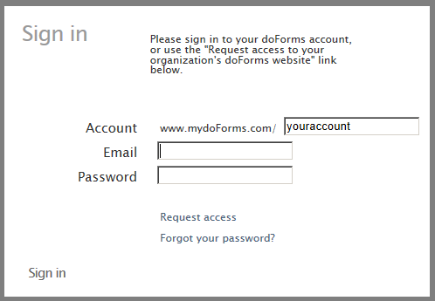

- Enter all of the information on the Request Account form and press Submit

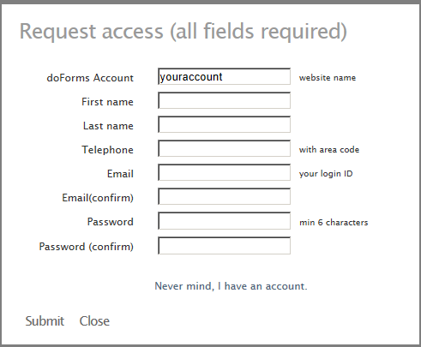

A doForms Administrator will review your request and email you a confirmation if access is granted.

Sign in

To login to your doForms website:

- Enter the name of your doForms website
- Enter your email address.
- Enter your password.
- Press Sign in.

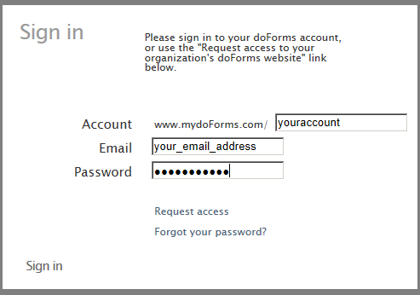

Sign out

There are two ways to log out:

- Click Sign out at the top right of the header
-OR-
- Close the browser

Website Home

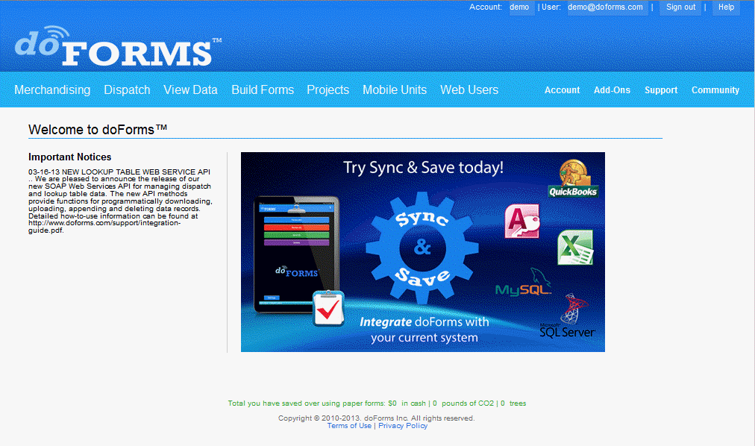

The doForms website has a consistent and easy-to-follow design as shown below. When you login, you will see the website homepage. The number of tabs and menu items will vary depending on your privileges.

Header Tabs

The header contains a light blue bar with links to the main sections of the website. Click those links to navigate to that page. The header is always visible, regardless of what page you are viewing. The main sections, from left to right, are:

Merchandising – [Merchandising Accounts only – visible / accessible to all users] Provides specialized merchandising functionality, including the ability to manage retail account and product facings. NOTE – This functionality is currently in “beta” and has not yet been released.

Dispatch – [Dispatch Accounts only – visible / accessible to all users] Provides the ability to dispatch work and job orders to your mobile workers and track their progress.

View Data – [visible/accessible to all users] Provides access to data submitted by mobile units connected to this doForms website, including query, sorting, viewing, mapping and exporting to other business applications.

Build Forms – [visible/accessible to users with Manage or Admin privileges] Provides an easy-to-use graphical tool for creating your own forms. Also provides access to the Public Forms Library.

Projects – [visible/accessible to users with Manage or Admin privileges] Organizes your forms into one or more projects.
Mobile Units – [visible/accessible to users with Manage or Admin privileges] Specifies which mobile devices are allowed to connect to this website. Also specifies which mobile devices subscribe to which specific projects.

Web Users – [visible/accessible to users with Manage or Admin privileges] Use to manage who can access this website and with what privileges.

Account – [visible/accessible to Administrators only] Provides additional website and mobile device administration functions. Provides access to SOAP web services that can be used by other business systems.

Add-ons – [visible/accessible to All users] Provides information on add-on products.

Support – [visible/accessible to All users] Provides access to the doForms support system.

Community – [visible/accessible to All users] Provides access to the doForms user and support forums.

Understanding Forms, Projects & Mobile Units


Forms
Projects
Mobile Units
doForms is designed from the ground up to make it easy to manage your mobile workers. We do this by providing two tiers of control:

Forms are organized into Projects – Think of the projects in literal terms (i.e., a job folder) or in organizational terms (e.g., a job function). For example, if you are a construction manager, you might want to group all the forms pertaining to a certain building in one project. Or, if you are a medical clinic, you might want to group all the forms used by your traveling nurses. Now here is the most important part – any form can be assigned to more than one project! This allows you to maintain a set of standardized forms that can be assigned to specific job folders or job functions. Projects are managed in the Projects tab of your website.

Projects are subscribed out to the Mobile Units – Any project can be subscribed out to any number of mobile units. And the mobile units do not need to subscribe to the same projects. Following through with our examples above, the project pertaining to a certain building can be subscribed out to just those workers at that job site. And the traveling nurse project can just be subscribed out to your traveling nurses. This level of control allows you to control who gets which projects and which forms. The subscriptions are managed in the Mobile Units tab of your website.

The “Main Project” – While the concepts above provide lots of flexibility they also require some effort. So we added a way to simplify organizing and deploying forms for those of you in a hurry. Your doForms account starts out with one “Main Project” which provides you with useful forms. When you save a form as Published it is automatically assigned to the Main Project, and the Main Project is automatically subscribed out to all mobile units. So if you create forms which you want to deploy to all mobile units, using the Main Project is an easy way to do so (more on this in the Build Forms section).

Deploying Forms to Mobile Units

There are a number of ways to deploy forms to your mobile devices:

From the Build Forms tab - The simplest and fastest way is from the Build Forms tab. Open the Draft form that you wish to deploy, go to the File menu and Save as > Published. This will save the form in a Published state and automatically add it to the Main Project. All of the mobile units that subscribe to the Main Project will automatically receive your form. Note that all mobile units are subscribed to the Main Project by default until you manually unsubscribe them in the Mobile Units tab.

From the Projects tab – The other way to deploy your form is to use the Projects tab. This method provides you the greatest control over who gets which form. First, in the Build Forms tab go to the File menu and Save as > Published (if you haven’t done so already). Next, go to the Projects tab and manually select which projects the form is added to. Just those mobile units that subscribe to those selected projects will receive the form. This allows you organize and deploy your forms by work-function. For example, if you created a “Field Inspection” form, you can add it to a “Field Project” which only your field workers are subscribed to. Use the Mobile Units tab to control which mobile units subscribe to which project.

In either case, your Published form will automatically be pushed out to all mobile devices that subscribe to the corresponding projects. And every time save the form as “Published”, those mobile devices will automatically receive the updated form.

IMPORTANT: Once a form has been Published, please be sure to notify your mobile users that they must “Update Forms and Notices” in their doForms mobile app. Otherwise, they will receive the Published form until the next time they exit and restart the doForms mobile app (when the update happened automatically).

Viewing Data

See “View Data” section.

Sending Dispatches and Work Orders

See “Dispatch” section.

Important Notices

Important notices are messages that are posted by your organization’s doForms Administrator or by the doForms System. These are managed in the Account tab.

Getting Started

Provides a link to the Website Introduction Videos

Custom Branding (Paid Accounts Only)

The branding for your doForms website and mobile app can be changed to reflect your organization’s identity. This includes replacing the doForms logo graphic with your own. These branding options are managed in the Account tab.

View Data

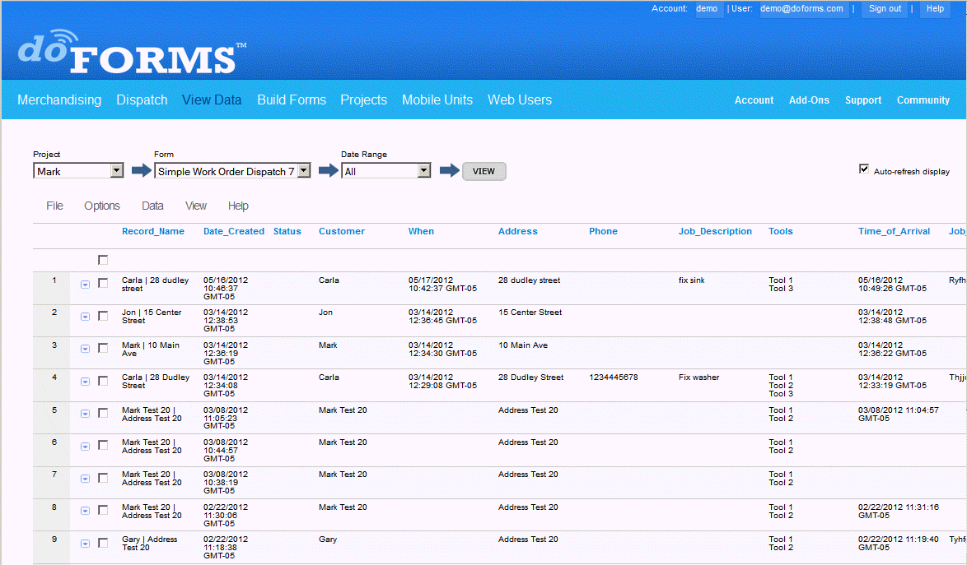

Selecting Projects and Forms

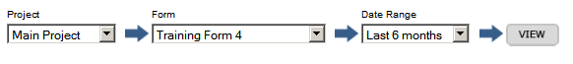
Your doForms database is organized by “Projects” which in turn contain the “Forms”. Note that the forms contain and organize the data, and any form may be listed under multiple projects (See Understanding Forms, Projects and Mobile Units).

To view data first Select a Project from the drop-down list. Next Select a Form. Next enter a Date Range. These will narrow down the volume of data that will be displayed. Finally, click the View button.

The data corresponding to the selection will be displayed. You can control how many data rows are displayed on a page using the controls at the top and bottom right side of the page.

Deleting Projects and Forms

In order to delete all the data corresponding to a form from your account, you must (1) delete the form in the Build Forms tab, and (2) remove the form from any projects in your account.

See the Build Forms section for information on deleting forms from your account.

See the Projects section for information on removing forms from projects in your account.

Deleting Data Records

In order to delete any or all records from your doForms website:
- Select a project/form in the View Data tab
- Select the record that you wish to delete using the checkboxes on the left side of each record (or check the box above all the records to “select all”)
- Click the “Delete all selected” button

File Menu

The File menu provides the following functions:

Save Data As – Allows the currently displayed data to be exported onto your local hard drive in Excel, CSV, HTML, Text, KML, OpenOffice or PDF formats. You can also export the data into your online Google Docs account. Once it is exported into your Google Docs account, you can perform a variety of spreadsheet, analysis and reporting functions on the data, as well as share it with other Google Docs users. When selecting the Google Docs option, you will be prompted for your Google Docs username and password, and you will also be asked to grant permission for doForms to connect with your Google Docs account.

Print – Prints the currently displayed data. Be sure to select “Landscape” layout in your browser print preferences. If you need additional formatting for your printouts, try one of the “Save as” options to get the data into another program, like Google Docs or Excel, then do the additional formatting in that program.

Import Data – The Import Data function allows you to import data from an external table into the Dispatch tab. External files can be CSV or Excel 97-2003 format only and first row of the file must contain field names for each column (no spaces or special characters). The corresponding data types (number, text, date etc.) must match the data types in the View Data tab exactly. The Import Data function will allow you the option of “mapping fields” in the event that the column names in the file and the data_names in the View Data tab do not match. Note that the maximum file size that can be imported is 5MB. If your file is larger, please break it up into smaller files and import them one at a time.

IMPORTANT: Note that it is the currently displayed data (i.e., the Current Query) that is processed by the options above (see “Sorting and Filtering Data” below).

Options Menu

The Options menu provides the following functions to display how data is presented in the View Data tab:

Display Settings – Use to specify which questions will be displayed as answer columns in the List View. Use these setting to un-clutter the List View. You may also specify if the “caption” or “data_name” property of the question widget will be displayed as the heading for the corresponding column. These settings are “per user”. This means that each web user can change the setting for a specific project/form without affecting other users.

Export Settings – Use to control how data will be exported with File > Save as options. “Column Headings” specifies if the “caption” or “data_name” property of the question widget will be displayed as the heading for the corresponding export column. “Choose-one questions” specifies how the answers to these questions will be exported. “Select-multiple questions” specifies how the answers to select-multiple questions will be exported. Options for choose-one and select-multiple include reporting “underlying values” in one column, or as “0/1” values in multiple columns. These settings are “per account”. This means that any changes to these settings for a particular project/form affect all website users.

Report Settings – Use to control the format of PDF and Excel reports. These settings are “per account”. This means that any changes to these settings for a particular project/form affect all website users.

Map Callout Settings – Use to specify which questions/answer fields will be included in the map callouts in the Map View. The “callouts” are small data summaries which are displayed when a map icon is clicked. See the illustration below. These setting are “per user”. This means that each web user can change the settings for a specific project/form without affecting other users.

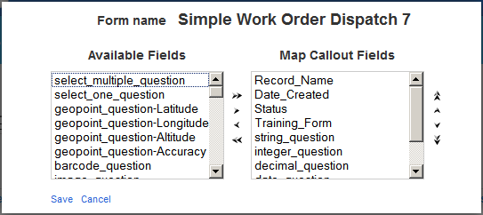

Data Menu

The Data menu provides the following functions for managing data in the View Data tab:

Add Record – Adds a new blank record into the data table in Edit mode.
Show Data Filter – Displays the data filter options. See “Sorting and Filtering Data” below.
Delete All Selected – Deletes all selected (checked) records.
Unlock All Selected – Unlocks all selected (checked) records.
PDF Report All Selected – Creates PDF Reports for all selected (checked) records. See “Creating PDF Reports” below.
Excel Report All Selected – Creates Excel Reports for all selected (checked) records. See “Creating Excel Reports” below.

View Menu

The View menu provides the following functions:

View Map – Toggles from List View to Map View (See Map View section below.)
List View – Toggles from Map View to List View

Viewing Media Files

Media files are listed in the “Media” column. When clicked, the media file will open in a new browser window.

IMPORTANT: Please make sure that your web browser is set to “Allow Pop-ups” from your doForms website in order to view the media files.

Sorting and Filtering Data

You can sort data alphabetically or numerically by clicking the column headings (e.g., ”integer question”).

To filter what data is displayed in the list view:

- Click the Data menu and select “Show Data Filter”
- Use search boxes, range boxes and drop down menus in most columns to define a “filter”
- Click Apply to apply the filter. The resulting list view will contain just those records that meet the constraints of the filter (we refer to this subset of data records as the “Current Query”)
- Click Clear if you wish to clear the filter and display all records
- Click Hide to hide the filter

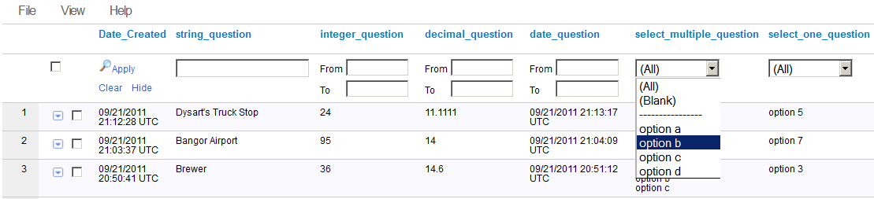

IMPORTANT: The doForms website has limited capability to do complicated filtering of large data sets. When these limits are reached, a warning dialog will be displayed. In this case, please try selecting a narrower “Date Range” at the top of the page, then repeat the steps above. If you exceed these limits but still need to perform complicated filtering, then please contact premier@doforms.com for information about our Premier Account options which provide additional server resources.

IMPORTANT: In addition to controlling which data records will be displayed in the list view, the “Current Query” that results from the filter operation also controls which data records will be printed, exported and mapped.

Current Query

The combined specifications of the Data Range and Filter result in a subset of form data being displayed. This subset is referred to as the Current Query. Note that all the operations in the File menu are performed on the Current Query. So, for example, if you use the File > Save as the option to export data, it will be the data records in the Current Query that are exported. Similarly, if you use the View > Map View option, it will be the data records in the Current Query that are mapped (see below).

Map View

To display all the data records in the Current Query on a map, select View > View Map. A new browser window will open with the selected data record icon displayed on the map (see below). Be sure that your browser is not set to block pop-ups. Click on any of the icons to display the data values for the record being mapped.

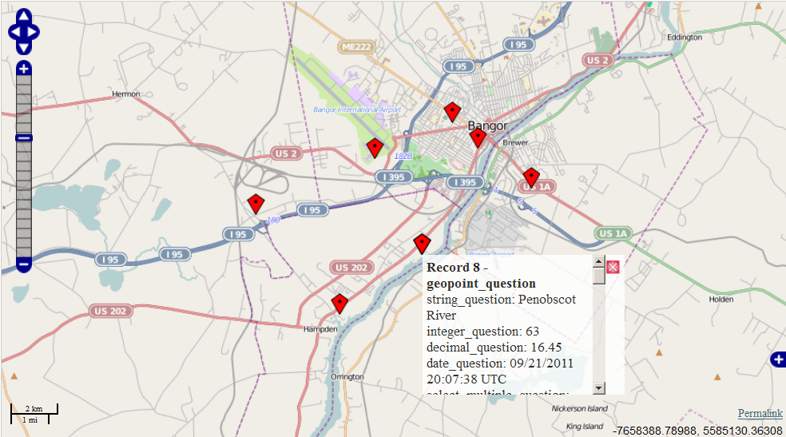

Row Menu

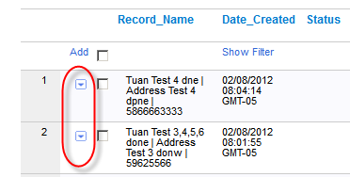

Each data row in the View Data tab contains a “Row Menu” (little boxes with down-arrow). The Row Menus in the View Data tab provide the following functionality:

Map – Displays the data for this row on a map (will only be displayed if data row contains GPS map coordinates). To display data in a row on a map, select Map from the Row Menu. A new browser window will open with the selected data record icon displayed on the map (see below). Click on icon to display the data values for the record being mapped.

Edit – Allows you to edit the data. To make changes to data in a row, select Edit from the Row Menu. The selected row will expand. Make the desired edits and press the Submit when done. The changes will be saved to your doForms website. Otherwise, press Cancel.

Add – Allows you to add a new data row below. To add a new row of data, select Add from the Row Menu. The new empty data row will be added below. Fill in the data fields and press the Submit button when done. The new row will be saved to your doForms website. Otherwise, press Cancel. Note that if the form has a media question, you will be able to upload the corresponding media files from your local hard drive if desired.

PDF Report – Produces a PDF report of the selected record. For more information, see the “Creating PDF Reports” section below. PDF reports can be downloaded, emailed or printed.

Excel Report – Produces an Excel report of the selected record. For more information, see the “Creating Excel Reports” section below. PDF reports can be downloaded, emailed or printed.

Delete – Deletes the data row. To delete a row of data, select Delete from the Row Action Menu. A message will be displayed asking you to confirm the delete. Click the Ok button to permanently delete the row of data from your doForms website. Otherwise, press Cancel.

Task – Use to send an email to one or more doForms website users instructing them to complete a task(s) pertaining to the data row. The email will contain a direct link back to the data record.

IMPORTANT: Edit, Add and Delete functions are only available to users with Edit, Manage or Admin privileges. Also, please make sure that your web browser is set to “Allow Pop-ups” from your doForms website in order to use the Print, Email PDF and Task functions above.

Creating PDF Reports

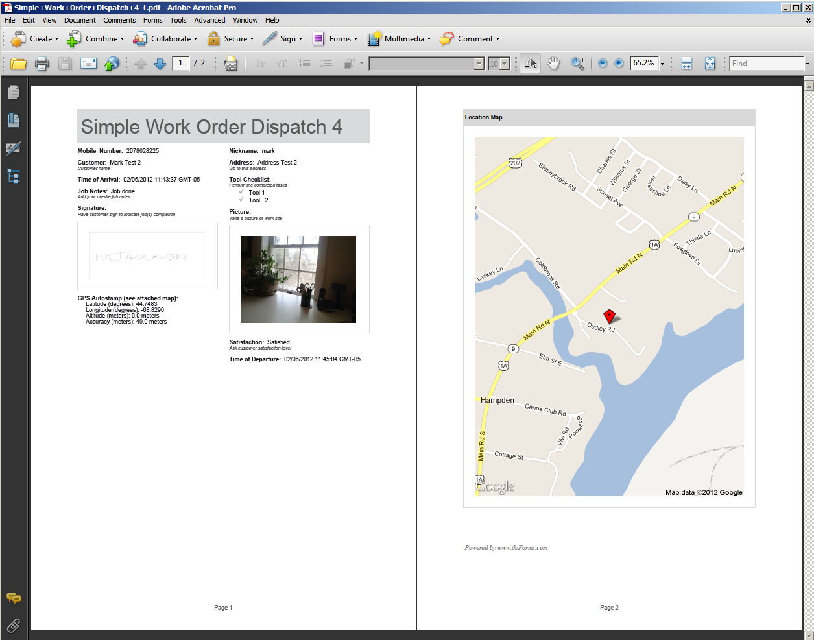

To print, email or save individual PDF documents for one record at one time:

- Go to the View Data tab and select the desired form.
- Click on the Row Menu of the row that you wish to print, email or save as a PDF (the Row menu is the little box with the down arrow at the left of each row).
- Select PDF Report.
- A new window will open with a Print Preview (make sure pup-ups are not blocked in your browser).
- At the top of the new window you can select either Print, Save or Email.
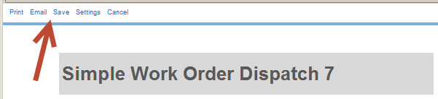

To create and save individual PDF documents for multiple records at one time:

- Select the records by checking them in the View Data tab.
- Click on the Data menu and select “PDF Report all Selected”
- What steps happen from here will depend on your browser type and version, but you will be able to save PDF reports for the checked records onto your local computer without the need to do so individually.

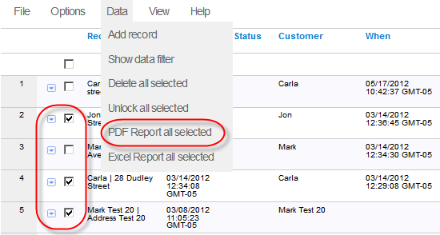

IMPORTANT: Please make sure that your web browser is set to “Allow Pop-ups” from your doForms website in order to view the Print Preview.

IMPORTANT: The current upper limit on the size of a single PDF file is 35MB. If you exceed this limit, doForms may replace inserted picture with http links to the picture in order to reduce file size.

Report Settings

To control the format of the PDF and Excel reports:
- Click on the Options menu
- Select Report Settings

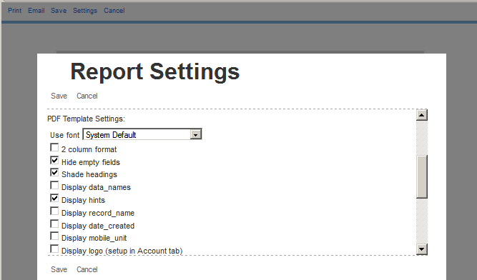

- After making the desired changes, click Save.
If you change the page settings for a particular project/form on the website as described above, then those setting will also get applied whenever a PDF for this particular project/form is sent from the mobile app.

PDF Template Settings

Font – Specifies the font to be used. The “System Default” font should be used for most latin-based alphabets. Specialty fonts should be selected for other alphabets (e.g., Cyrillic for Greek or Russian)
2 column format – The default layout is single-column. Selecting this option will format the report in two columns.
Hide Empty fields – Hides any questions that have not been answered.
Shade headings – Shade the “caption” property of Label question widgets in the form..
Display data_names – The default is to display the “caption” property of question widgets. Selecting this option will display the “data_name” property instead.
Display hints – Display the “hint” property of the question widgets in the form.
Display record_name – Display the system generated “record_name”.
Display date_created – Display the system generated “date_created”.
Display mobile_unit – Display the mobile number of the device that submitted this form.
Display Logo – Display a custom logo if one has been uploaded to your doForms website (see Admin tab section). (Paid Account Only)
Display page numbers – Include page numbers at the footer of the PDF.
Display GPS coordinates on map – Display GPS coordinates (if any) on a location map which will be appended to the PDF or Excel file. Use the “Auto-scale” option to let doForms select the best map scale that fits all the GPS points. Use the “Enter scale” option to manually specify a scale. 0 is lowest detail. 20 is highest detail. Highest detail maps may not be available for all locations.
Page widget starts a new page – Creates a page break in the PDF report wherever a Page widget is inserted into a form.
Each loop in a Repeatable Section starts a new page – Creates a page break at the beginning .

Excel Template Settings

Select an Excel Template file – Specifies the Excel Template file that will be used to format Excel reports (see the Creating Excel Reports section below).

General Report Settings (PDF & Excel Reports)

Always populate defaults – Checking this option causes default values to be displayed in PDF and Excel reports.
Resize images - Allows you to specify a reduced image size as a percentage of the original – 100%, 66%, 50%, 33% and 25%. This option allows you to better control the format of your reports, and it also allows you to reduce the size of the resulting PDF or Excel files.

Creating Excel Reports

In addition to the PDF report format described above, doForms allows you create Excel reports of your data. Excel reports have a number of advantages over PDF reports:

- Provide much greater control over format of the report
- Can apply Excel calculations and functions on your data
- Can include Excel charts and graphs generated from your data

Excel Reports a created using an “Excel Template” file. These template files are simply Excel worksheets that have been “Saved as … Excel 97-2003 Template”. Note that doForms ONLY recognizes the Excel 97-2003 format. The examples below show an Excel Template file that you create and the corresponding Excel Reports generated by doForms. But to understand how Excel Report Templates work in doForms, you need to understand how the “data_name” property of the questions in your reports are used to “map” data values into your Excel Report.

Excel Report Template: Excel Report File:
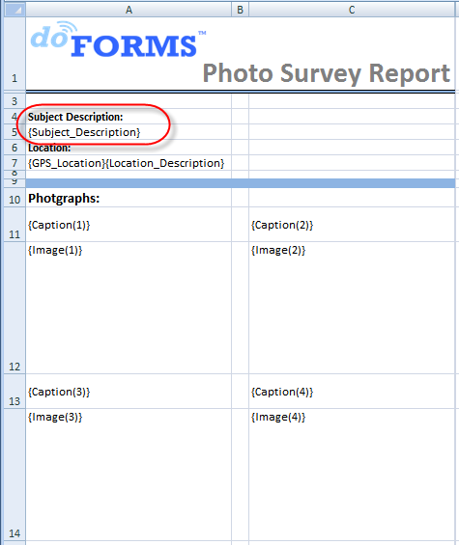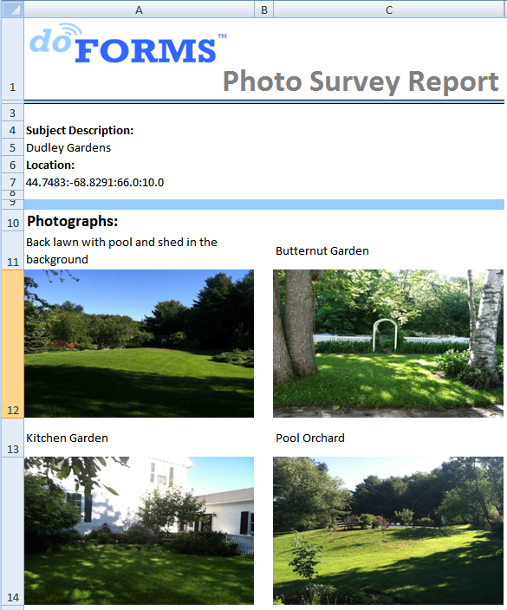

{data_name} Tags

Data_names are unique identifiers that you set up in the Properties of each of the questions in your form. These unique identifiers are used throughout the data collection and data management process to organize your data as shown below.

Data_Name Property in the Build Forms tab:
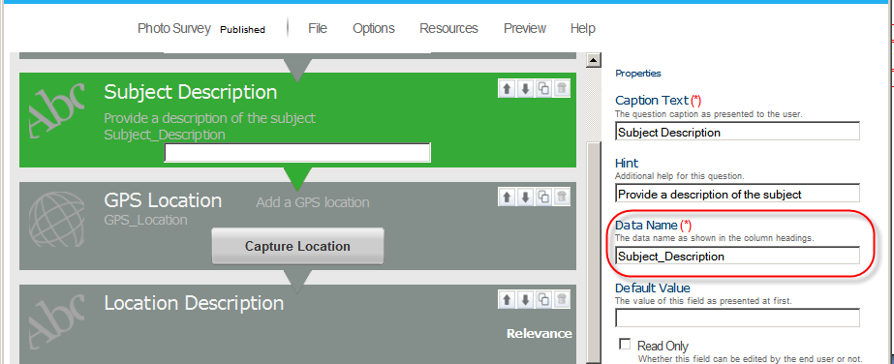

Data_Name Property in the View Data tab”
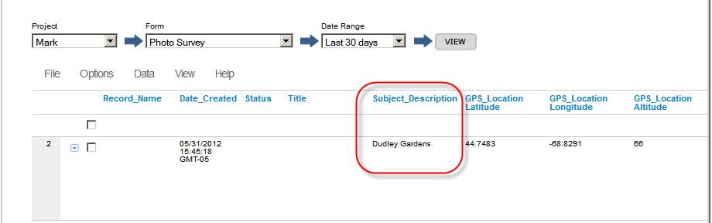

doForms uses these same data_names to relate (or “map”) the answers being collected in your form to cell locations in the Excel Template. For example, the Photo Survey form above contains a text question with the data_name “Subject_Description”. As the name implies, this is where a mobile user enters description text for their photo survey. Note how the Excel Report Template below utilizes the same data_name to specify where these values will be displayed in the report using the “{ }” brackets. This tells the doForms to “map” the answers to the Subject_Description to that particular cell. In the View Data screen above there is a competed record with the Subject_Description = “Dudley Gardens”. Note how this answer value is mapped to the completed report below.
If your form includes Repeatable section or Table containers, the format of the corresponding data_name tags is as follows: {data_name(i)} where “i” is the repeat number. So in the Excel Template example above the captions and images are specified as {Caption(i)} and {Image(i)} respectively. This is also the data_name format used to reference data in grid tables.

Creating a Template

Follow these steps to create an Excel Report Template for use with doForms:

- Open Excel and start a new worksheet
- Specify which cells will contain which answers with the {Data_Name} tag
- Add titles, captions, and any other text into their own cells and format as desired
- Add any desired graphics, such as logos, using the Excel “Insert” functions
- Add any desired page breaks using the Excel “Layout” functions
- If your report includes numeric values, add any desired formulas or charts then employ these values
- Use the Excel File > Save as function to save the file in one of the Excel 97-2003 and Excel 2010 Template formats as shown below (xlt, xltx, xltm).

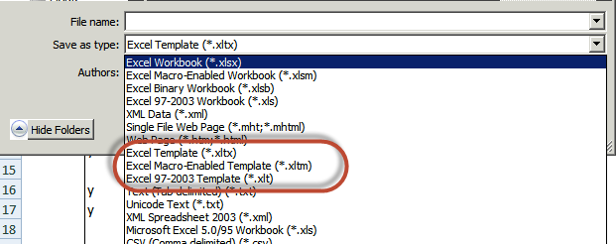

Multiple Worksheets/Tabs

Excel Report Templates that you create can employ one or more worksheets/tabs in the Excel file. This permits better report organization for forms with many data values.

Multiple Projects/Forms

Excel Report Templates can also be created and used to aggregate data from different forms into a single report. Note that this is for different forms, NOT for different data records of the same form. The format is as follows:

{"project"="Project_Name","form"="Form_Name","common-field"="Data_Name","field"="Data_Name"}

Where:
- Project_Name is the name of the project that contains the data
- Form_Name is the name of the form that contains the data
- Data_Name is as previously described
- Common-field is the Data_Name value of the common field

So for example, assume that I have two forms in a project named “Insurance” for which I want to aggregate the data from two different forms. The first form is named “Car” which contains data about a customer’s car. The second form is named “House” which contains data about a customer’s house. Both forms contain the common-field called “Customer_ID” which is a unique numeric number to identify each customer. If we wish to create {…} tags in the aggregate report to display the customer’s {car_make} and {house_contsruction} we would use:

{"project"="Insurance","form"="Car","common-field"="Customer_ID","field"="car_make"}
{"project"="Insurance","form"="House","common-field"="Customer_ID","field"="house_construction"}

Note that you only need to use the long format of the {…} tag above if data is being read from a form that is different from the form that the report is being generated for. So for example, if we were generating reports for the House form, we could simply use the tag {house_construction}. But if we want to include data from the Car form in the report for the House form then we would need to use the long format of the {…} tag. Similarly, if you wanted to use the same Excel Report Template for generating the same report for both the Car form and the House form, then you would need to use the long form of the {…} tags.
Restrictions:
- All values inside the {…} tag are case-sensitive and cannot contain any special characters, including \ / : * ? " > < | = { }.
- Common-field fields are restricted to text, numeric-integer, lookup and barcode question types
- Common-fields must be unique. So in the example above, no two customers can have the same ”Customer_ID”
- No single form can contain more than one data record that has the same value of the common-field. So in the example above, the Car form and the House form can NOT contain more than one record each with the same value for the “Customer_ID” field.
- If any of the restrictions above are violated, an error will occur in the report that is generated.

Uploading the Template

After the Excel Report Template has been created on your PC, follow these steps to upload it to your doforms website:

- Go to the Build Forms tab of your website
- Click on the Resources menu
- Select Manage Excel Templates
- Click Add
- Click Upload Excel File
- A “File Upload” dialog will open. Browse the files then select your Excel Report Template file and click Open
- Give your template a name and description, then click Save
- Your template will be added to the Saved Excel Templates list
- Click Close

See the “Build Forms” tab section of this user manual for an illustrated version of the steps above.

After you upload a report template, this template becomes available for use with any form in your account provided that the form has exactly matching data name and common-field values for the {…} tags.

Using the Template

After the Excel Report Template has been uploaded to your website, follow these steps to specify how it will be used in generating reports:

- Go to the View Data tab of your website
- Open the project/form that you wish to use the template with
- Click the Options menu
- Select Report Settings
- The select the Excel Report Template you wish to use
- Indicate if Excel Template will also be used by the mobile app when emailing reports
- Click Save

To create an Excel Report from the View Data Tab:

- Go to the View Data tab of your website
- Open the project/form that you wish to use
- Click the Row Menu on the record your wish to generate a report for (little box with down arrow)
- Select Email or Save (note that Excel Reports cannot be previewed or printed on the doForms website)
- Open the file in Excel or any program that reads Excel documents.

To create and save individual Excel Reports for multiple records at one time:

- Select the records by checking them in the View Data tab.
- Click on the Data menu and select “Excel Report all Selected”
- What steps happen from here will depend on your browser type and version, but you will be able to save Excel reports for the checked records onto your local computer without the need to do so individually.

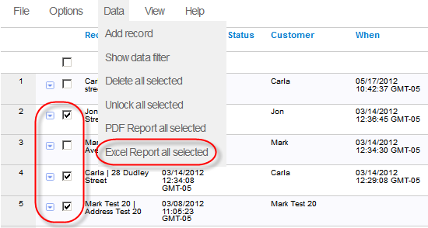

IMPORTANT NOTES:

- doForms only recognizes Excel 97-2003 and Excel 2010 Template formats (xlt, xltx, xltm).
- Certain features of Excel will not be supported in the template. These include shape drawings, smart-art, certain chart types, and others.
- Text and number values can be placed into “merged” cells, but photos and signatures cannot be placed into merged cells.
- In most cases, you may place multiple data_name tags in a single cell
- If you specify the data_name for a GPS location, both the latitude and longitude values will be written into the same cell but separated by a comma.
- Images will be automatically scaled to the cell size in the Excel Report Template. Be careful with aspect rations.
- For audio and video files, doForms will insert the http:// address of the corresponding media files.

Emailing Reports from the Mobile App (Paid Account Only)

In order to email a PDF Report or Excel Report from the doForms mobile app, you must insert an “Email Report” question widget into the form when building it. The position of the “Email Report” question widget in the form does not matter. The PDF will be sent at the same time as the completed form is sent to your doForms website. To add an “Email Report” question widget into the form:

- Open the form in the Build Forms tab.
- Drag and drop the “Email Report” question widget into the desired location.
- Save your form when done.
To control the format of the PDFs, use the PDF Page Settings as described in the previous section.
If you change the PDF Page Settings for a particular project/form on the website as described above, then those settings will also be applied whenever a PDF for this particular project/form is sent from the mobile app.

Similarly, to control the format of the Excel Reports, use the procedures described in the prior section. If you change Excel Report Template for a particular project/form on the website as described above, then that template will also be applied whenever an Excel Report for this particular project/form is sent from the mobile app.

Workflow Approvals

Workflow approvals are a special question type that can be inserted in one or more places within a form in the Build Forms tab. These approvals are not displayed in the doForms mobile app, but they are displayed in the View Data tab. The approval status can then be changed by the responsible Web User, and the data record is “stamped” with that specific Web User’s login ID. This stamp cannot be edited and serves as a digital approval signature.

If you are the individual that is responsible for approving form submissions:
- Login into your doForms website
- Select a project/form in the View Data tab
- Navigate to the desired row and select Row Menu > Edit
- Navigate to the Approval column
- Click on the dropdown menu and select “pending”, “approved” or “rejected”. The corresponding status will be stamped with your user ID.

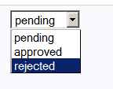

Viewer Control

You can control “who sees what” in the View Data tab by using the View Restriction parameter in the Web Users tab. This parameter allows you to restrict the viewing of records to those submitted by a specific device Mobile Number. For example, if you have multiple sales people accessing the View Data tab, you can specify that any particular salesperson can only view/edit the records which they submitted, by specifying their Mobile Number as the View Restriction. Please see the Web Users section for more information).

Retrieve Function (Dispatch accounts only)

http://www.doforms.com/support/how-to-videos/how-to-use-retrieve.htm

Dispatch accounts provide the ability for mobile users to “Retrieve” previously sent data from the website, work on it, then send it back to the website. Imagine a situation where you have one mobile worker who fills out a form, and a different mobile worker who needs to approve the job record. Or imagine a field medicine scenario where different specialists need to add information to a patient record.

Data records that have been “retrieved” by a mobile device are automatically “locked” on the website as shown below. Locking prevents the record from being retrieved by a different mobile user. Locking also prevents records from being edited on the website. This ensures that conflicting changes cannot be made at the same time.

The records are “unlocked” when they have been sent back from the mobile device to the website. Once unlocked, the can be retrieved again or edited on the website. Records are also “locked” during the time when they are being edited on the website, and unlocked automatically when the editing process has ended.

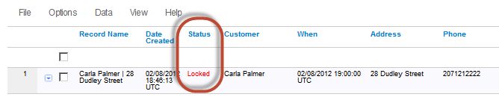

Individual data records can be manually unlocked on the website by:

- Selecting the desired records in the View Data tab
- Click the Data menu
- Select Unlock

The website also provides an automatic “unlock” function for any records that have been locked over specified period of time. The default is 24 hours, but this can be changed in the Account tab by clicking the Change Unlock Timeout option as shown below.

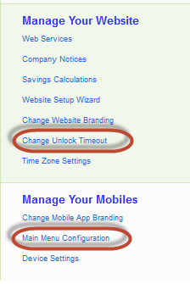

Finally, the Retrieve function on mobile devices can be enabled or disabled centrally in the Main Menu Configuration option in Account tab. Disabling hides the Retrieve button in the doForms mobile app so the function cannot be used.

Dispatch [Dispatch accounts only]

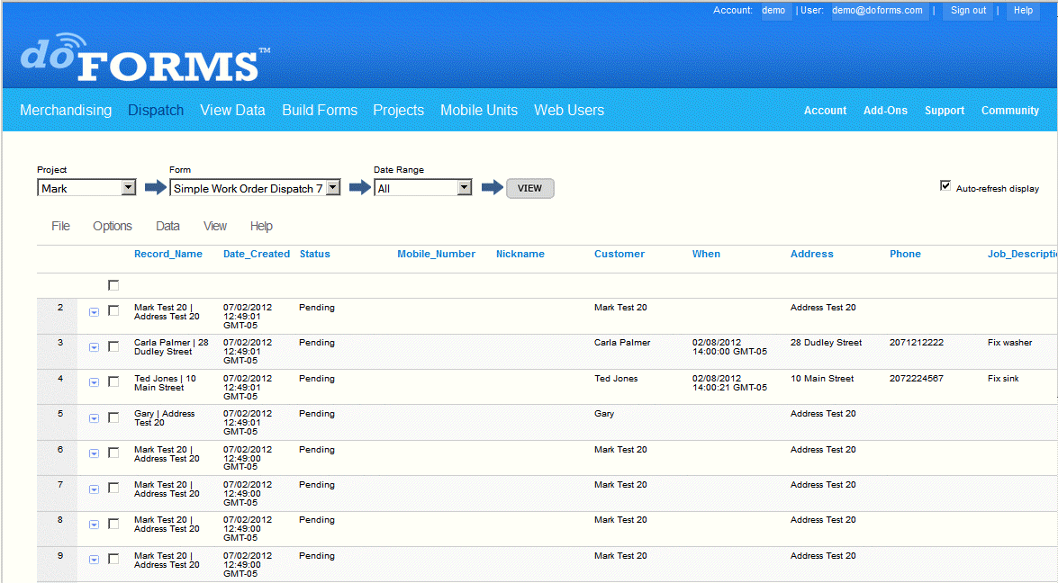

doForms Dispatch provides powerful dispatch forms and work order forms functionality. These special purpose forms contain important information to tell mobile workers where to go (dispatch) and what to do when they get there (work order). As your mobile workers complete their assigned tasks, doForms lets them fill out data fields in the form, take pictures, capture GPS locations, and collect signatures. The completed data records are then sent back to you. In addition to sending and receiving forms from your workers, doForms Dispatch also tracks their current and past GPS locations, and these locations are plotted on an interactive Tracking Map. You can select which workers to view, as well as the time interval. The map also shows the locations where forms were filled out.

http://www.doforms.com/support/how-to-videos/how-to-use-dispatch.htm

Selecting Projects and Forms
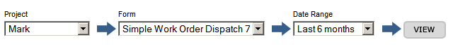
To view data first Select a Project from the drop-down list. Next Select a Form. Next enter a Date Range. These will narrow down the volume of data that will be displayed. Finally, click the View button.

Viewing and Deleting Dispatch Records

Viewing and deleting dispatch records works the same way as viewing and deleting data records in the View Data tab. See View Data section for more information.

Creating a New Dispatch Record

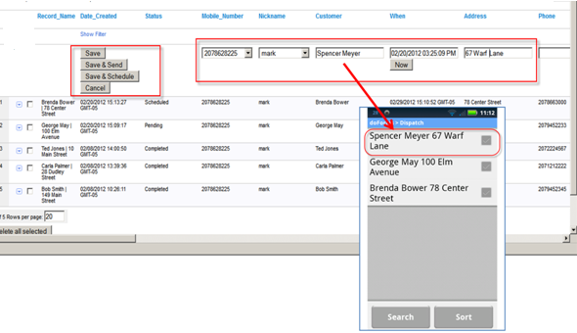

To create a new dispatch record:

- Click the Data menu and select “Add Record”Select the Mobile_Number or Nickname of the mobile device to which this record will be sent.
- Fill out any other desired fields in the form.
- Click on one of the Save options.

The Save options include:

Save – The record will be saved and listed as Pending.
Save & Send – The record will be saved, sent and listed as Sent.
Save & Schedule – The record will be saved, scheduled for future sending and listed as Scheduled.

Shown above is the form that was dispatched in the example after it is received by the doForms mobile app (Sent and Received).

Status Indicators

The Dispatch tab provides to following status indicators for each dispatch record:

Pending – The dispatch record has not been sent to the mobile device.
Scheduled – The dispatch record has been scheduled for sending.
Sent – The dispatch record has been sent to the mobile device.
Received – The dispatch record has been received by the mobile device.
Viewed – The dispatch record has been viewed on the mobile device.
Rejected – The dispatch record has been rejected by the mobile user.
Completed – The dispatch record has been completed by the mobile user.

Note that you can change the colors of the various status indicators in the Options menu.

IMPORTANT:
- Be sure that the dispatch interval on each mobile device is set to a non-zero value (Settings).
- The dispatch receiving function on the mobile device will continue to receive dispatches when doForms Dispatch is running in the background (e.g., you open another program without “exiting doForms”).
- The dispatch receiving function will be suspended if the mobile device goes to sleep (screen turns off).

File Menu

The File menu provides the following functions:

Import Data – The Import Data function allows you to import data from an external table into the Dispatch tab. External files can be CSV or Excel 97-2003 format only and the first row of the file must contain field names for each column (no spaces or special characters). The corresponding data types (number, text, date etc.) must match the data types in the Dispatch tab exactly. The Import Data function will allow you the option of “mapping fields” in the event that the column names in the file and the data_names in the Dispatch tab do not match.

Options Menu

The Options menu provides the following functions:

Display Settings – Use to specify which questions will be displayed as answer columns in the List View. Use these setting to un-clutter the List View. You may also specify if the “caption” or “data_name” property of the question widget will be displayed as the heading for the corresponding column. These settings are “per user”. This means that each web user can change the setting for a specific project/form without affecting other users.

Bulk Dispatch – Schedules all records that have a Pending status to be Sent at a future time (see “Bulk Dispatch” below).

Schedule All Pending – Schedules all records that have a Pending status to be Sent at a future time.

Send All Pending – Immediately Sends all records that have a Pending status.

Status Colors – Allows you to change the colors of the various status indicators. These setting are “per account”. This means that any changes to these settings for a particular project/form affect all website users.

Report Settings – Use to control the format of PDF and Excel reports. These setting are “per account”. This means that any changes to these settings for a particular project/form affect all website users.

Data Menu

The Data menu provides the following functions for managing data in the View Data tab:

Add Record – Adds a new blank record into the data table in Edit mode.

Show Data Filter – Displays the data filter options. See “Sorting and Filtering Data” below.

Delete All Selected – Deletes all selected (checked) records.

View Menu

The View menu provides the following functions:

Tracking Map – Toggles from List View to the Tracking Map (See Tracking Map View section below).

List View – Toggles from Tracking Map to List View.

Sorting and Filtering Data

Sorting and filtering dispatch records works the same way as in the View Data tab. See View Data section for more information.

Row Menu

Each data row in the Dispatch tab contains a “Row Menu” (little boxes with down-arrow). The Row Menus in the View Data tab provide the following functionality:

Send – Use to send the dispatch record to the designated mobile device.

Schedule – Use to schedule the Send function for a future date and time.

Edit – Allows you to edit the data. To make changes to data in a row, select Edit from the Row Menu. The selected row will expand. Make the desired edits and press the Save when done.

Add – Allows you to add a new dispatch record (see the “Creating a New Dispatch Record” section above).

Print – Prints the data row in a summary format. To print a row of data, select Print from the Row Menu. Note that the print function is limited in its formatting capability. If you need more control over the format of your output, please export your data to Excel, apply the desired formatting in Excel, and print from Excel. The print control also allows you to email a PDF.

Email PDF – Access this function by clicking Print in the Row Menu.

Delete – Deletes the data row. To delete a row of data, select Delete from the Row Action Menu. A message will be displayed asking you to confirm the delete. Click the Ok button to permanently delete the row of data from your doForms website (Dispatch tab and View Data tab). Otherwise, press Cancel.

Task – Use to send an email to one or more doForms website users instructing them to complete a task(s) pertaining to the data row. The email will contain a direct link back to the data record.

IMPORTANT: Edit, Add and Delete functions are only available to users with Edit, Manage or Admin privileges. Also, please make sure that your web browser is set to “Allow Pop-ups” from your doForms website in order to use the Print, Email PDF and Task functions above.

Bulk Dispatch

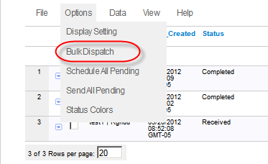

The “Bulk Dispatch” feature is used to dispatch more than one form at a time to a mobile worker. Supposed your company uses separate forms for work orders and customer satisfaction forms and you would like to be able to send both of these forms out to your mobile worker pre-populated with the same customer information. If the forms reside in the same project then the bulk dispatch feature will allow you to do this. To use the bulk dispatch feature:

- Click on the Options menu and select “Bulk Dispatch”. The Bulk Dispatch wizard will be displayed in a pop-up window.
- In Step 1 of the wizard, select the project that contains the forms you wish to dispatch (they must be in the same project). Select the forms you wish to dispatch. Click the Next button.
- In Step 2, the wizard will present any fields that are common to the selected forms. Enter any common values that you wish to pre-fill in the selected forms. Click the Next button.
- In Step 3 of the wizard, select the mobile number or nickname of the device that you wish to dispatch the selected form to. Then select one of the Save options.

Workflow Approvals

Workflow Approvals work the same way as in the View Data tab. See View Data section for more information.

Tracking Map

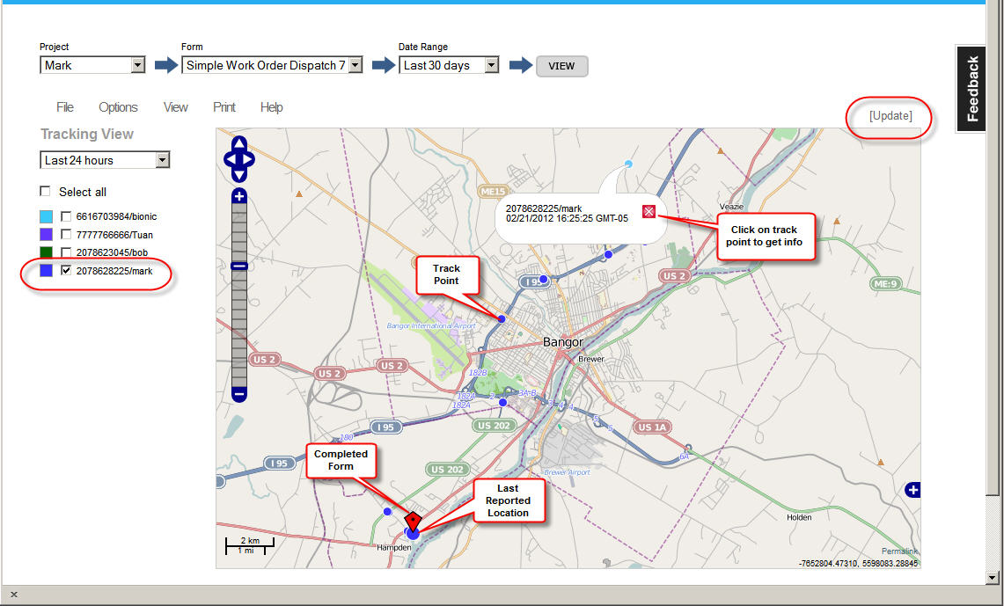

In addition to sending and receiving forms from your workers, doForms Dispatch also tracks their current and past GPS locations, and these locations are plotted on an interactive map in the Dispatch tab. You can select which workers to view, as well as the time interval. The map also shows the locations where forms were filled out.

To view the tracking map click on the View menu, then select Tracking Map.

IMPORTANT:
- Be sure that the tracking interval on each mobile device is set to a non-zero interval.
- The tracking function on the mobile device will continue to send GPS coordinates when doForms Dispatch is running in the background (e.g., you open another program without “exiting doForms”).
- The tracking function will be suspended if the mobile device goes to sleep (screen turns off).

Duration

Select a duration over which to display tracks. Locations are saved for up to 72 hours then automatically deleted from the doForms website. The last reported location will always be displayed as the largest circular icon for each mobile device.

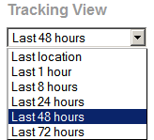

Track Colors

Select a color scheme for each mobile device listed in the Tracking Map.

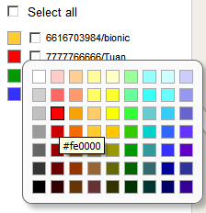

Build Forms

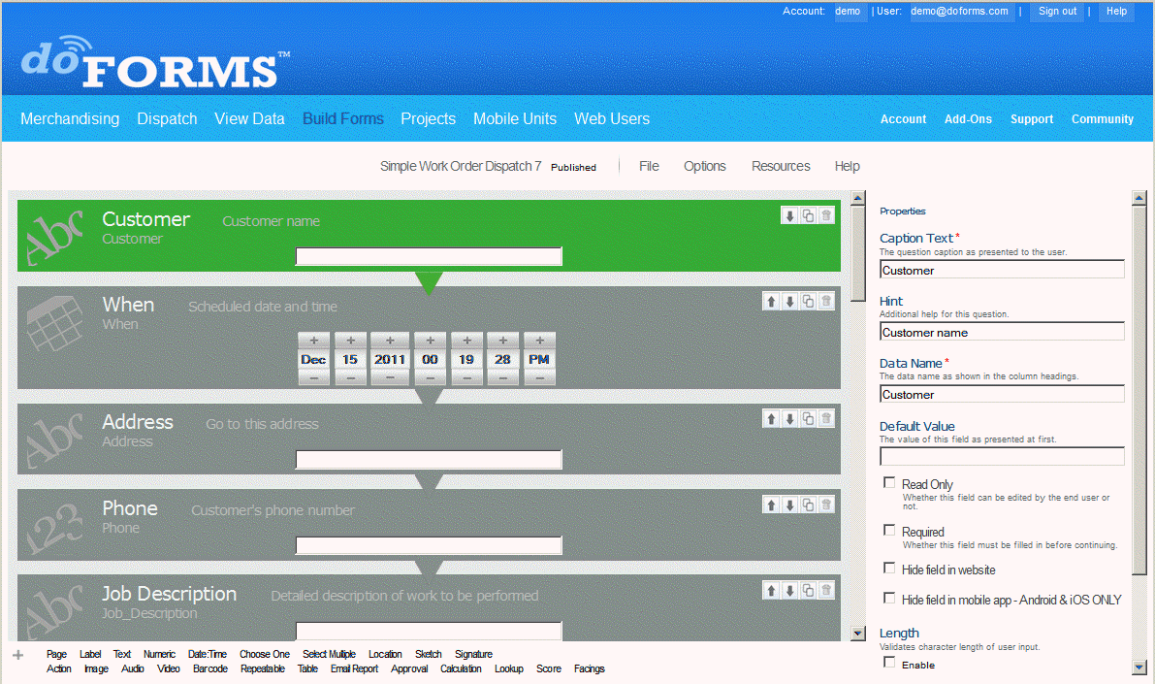

Layout

The Build Forms tab consists of two sections that work together as an easy-to-use, but very sophisticated, form creation tool. In addition to building a form from scratch, you use our Forms Library. Forms from the Library can be used directly or as a starting point for customization.

Form Canvas – The left hand side of the page provides a form canvas that illustrates the form. The “selected” question is highlighted in green.

Properties – The properties area on the right hand side of the page allows you to customize the “selected” question. Note that the available properties vary with the question type (see below).

Creating a Form

When you start the form builder, a blank canvas will be displayed with an untitled form. You may also use the File menu to select a form from the Forms Library which you can use as a starting point for further customization (see below). Note that all forms have two possible “states”:

Draft – This indicates that the form is a “work in progress” and not available to any mobile units.

Published – This indicates that a form is complete. Published forms are automatically added to the Main Project which is automatically subscribed to by all mobile units (see Deploying Forms section below for more information).

Opening a Form

To open an existing form, go to the File menu and select Open. Next, select the desired form from the list and click Open; otherwise click Cancel.

To open a form from the Forms Library, go to the File menu and click Open. The open dialog will be displayed. At the bottom of this dialog, click on “Select a form from the doForms Public Library”. See the Public Forms Library section below for more information.

Saving a Form

Always be sure to save changes to your form before navigating away from the Forms Tab.

To Save a Draft form under the same name, go to the File menu and select Save.

To Save a Draft form under a different name, go to the File menu and select Save Form As > Draft.

To Publish a Draft form, go to the File menu and select Save Form As > Published. When published, the form will automatically be added to the Main Project, and will be available to all mobile devices that subscribe to this project.

IMPORTANT: Once a form has been published under a certain name (say “Timesheet”), then that name cannot be used again in your doForms account (even after “Timesheet” has been deleted). This restriction is in place to prevent confusion about which data came from which version of a form. Therefore when publishing an update to a form you will need to use a different name (we recommend appending a letter or number to the form name, e.g., Timesheet-2 or Timesheet-B). The only exception to this rule is the File >Open Special option described below.

IMPORTANT: Once a form has been published, please be sure to notify your mobile users that they must “Update Forms and Notices” in their doForms mobile app. Otherwise, they will receive the published form until the next time they exit and restart the doForms mobile app (when the update happened automatically).

Open Special

As described above, if you use File > Open, make edits to a form, then use Save Form As > Published, a new name will need to be assigned to the form. This is because every version of a form corresponds to a specific data table structure. So, for example, if you add or delete questions, or change a Repeatable Section, the underlying data table structure changes, and hence a new data table needs to be set up in which to store the data.

However, there are instances where very “light edits” can be made to a form without affecting the data table structure. This may be done using the File > Open Special option , from where light edits may be performed, and from where you can File > Save with the same form name. In these cases the collected data will continue to be stored in the same data structure and same data table.

Light edits are defined as:
- Changes to the “Caption Text” property
- Changes to the “Hint” property
- Changes to the “Default” property
- Changes to the “Read Only” property
- Changes to the “Required” property
- Changes to the “Length or Range” property
- Changes to the “Auto-Stamp” property
- Changes to the number or names of the “Answer options” property in Choose-One, Select-Multiple and Score question types
- Changes to the “Data Source” or “Lookup Field” property in lookup table question type
- Changes to the “Skip” or “Relevance” properties
- Changes to the “Record Name” (see Options menu section below)

IMPORTANT: If you open a previously published form with the File > Open Special option , then be sure to use the File > Save option to save the changes using the same form name and same data table (do not use File > Save as …).

Insert Form

The build forms tab allows you to insert an already existing form into a form that you are working on. This is very handy if you have form elements which you use over and over in your forms. To Insert a form:

- Go to the File menu and select Insert Form. A list of available forms will be displayed.
- Select the form that you wish to insert, and click Insert.
- The selected form will be inserted at the bottom of the form that you were working on. From here you can drag and drop the questions to rearrange them as desired.

IMPORTANT: After inserting a form, you may need to edit the “Data Name” property of some of the questions to ensure that there are no duplicates. If you do so, you will also need to review and possibly edit any relevance and skip conditions which use these data names - likewise any affected destination fields in Lookup questions.

Deleting a Form

To Delete a form, first open it under the Build Forms tab, then go to the File menu and select Delete Form.

IMPORTANT: Note that the “data table” corresponding to the form will not be deleted by simply deleting the form from the Build Forms tab. To delete the corresponding data table and its data, you must also remove the form from any project in your account. See the Projects section for information on removing forms from projects in your account.

Options Menu

Record Name

Record Names are used to identify individual records (instances) of the same form. When you create a form in the Build Forms tab, the “Form Name” applies to all instances of the form. For example, in the “Simple Work Order Dispatch Form” below, all complete or incomplete records are assigned this same Form Name. Record Names that are made up of data values contained in the form are used to differentiate these records.

Record names are displayed in the doForms mobile app and also in each row in the View Data tab. In the example below, we assign record names by concatenating four fields in the form “Customer + Address”. In our application, when combined, these values identify each form record.

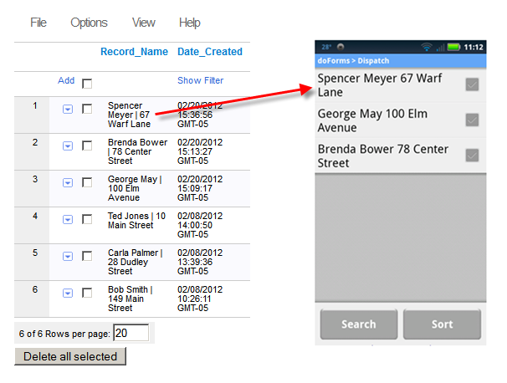

When specified, record names are also used as file-name values when creating PDF or Excel reports. If you plan on using record names for reports, then be sure that each record name is unique so that you do not over-write an existing file. If you are unsure, then add a date:time field to your record name to ensure uniqueness.

By default, the record name consists of “Form Name + Date:Time” when the record was created. To customize the Record name:

While the form is open in the Build Forms tab, click on the Options menu and select Record Names. Next, move the fields which you wish to use in the Record Name from left to right. Click Save when done. The Record Names dialog will close. Note that when you are done editing your form you will also need to publish the form using the File > Save as Published command for the record names to be applied (in other words, there are two “saves” that need to be done). .

If your form has previously been saved as “Published”, you may use the File > Open Special option to open it, then change the Record Name. Click Save when done. The Record Names dialog will close. Again, note that when you are done editing your form you will also need to save the form using the File > Save command for the record names to be applied (in other words, there are two “saves” that need to be done).

In the example below, the form name will consist of “Customer + Address + Phone”.

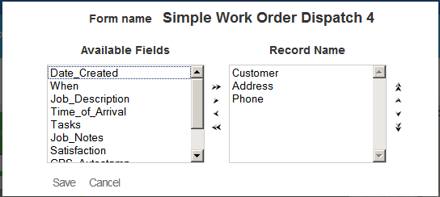

Resources Menu

The resources menu allows you to manage resources that can be used with one or more forms in your doforms account. This includes “Lookup Tables” and “Excel Report Templates”.

Manage Lookup Tables

http://www.doforms.com/support/how-to-videos/how-to-manage-lookup-data.htm

Lookup tables allow you to search and select an answer from an external data table. Also, if a lookup table row contains answers for other questions in your form, you can use the table to automatically answer these questions as well. For example, if your form contains questions for entering “Customer Name”, “Customer Number” and “Customer Address”, and if you have a lookup table which also contains these columns, then you can set up “Customer Name” as the lookup table, and when the mobile user searches and selects a Customer Name, the corresponding Customer Number and Number Address will be automatically filled out in the form.

See the “Using Lookup Tables” section below for more information about working with lookup tables.

To manage your lookup tables, click the Resources menu, then select Manage Lookup Tables. The dialog below will open with a list of all lookup tables that have been set up in the Build Forms tab. In the example below, three lookup tables have been set up.

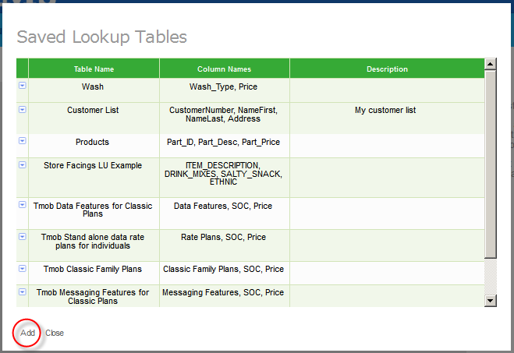

Adding a New Lookup Table from an External CSV or Excel 97-2003 File.

- Click Add to create a new lookup table.

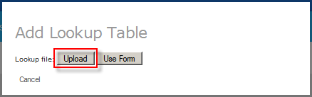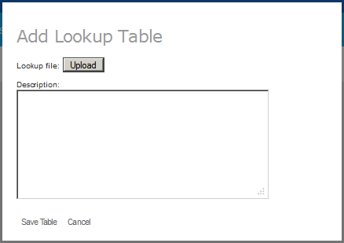

- Click Upload to select an external CSV or Excel 97-2003 file from your local computer which will be loaded into the lookup table.

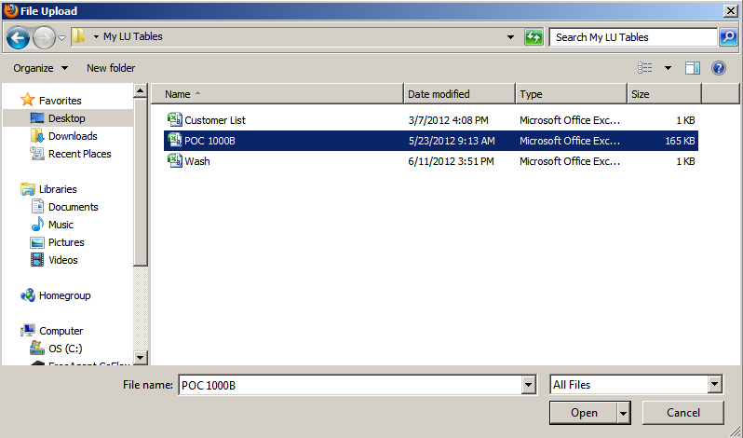

- Navigate to the file which you wish to use as the lookup table, select it and click Open.
- Type in a Description for this lookup table (optional).
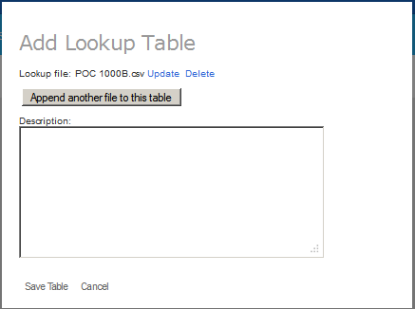

- To append a file, click Append another file and repeat the steps above. Appended files must contain exactly the same column names and data types.
- Click Save Table when done.

TIP: When you upload a lookup table, this table becomes available for use with any form in your account. So a single lookup table can be used by any number of forms, and in different ways. For instructions for setting up a form to use the lookup table, please refer to the “Using Lookup Tables” section below.

IMPORTANT: External files can be CSV or Excel 97-2003 format only. The first row of the file must contain field names for each column (no spaces or special characters). Each file must be less than 4 MB in size (see below how to append multiple files to overcome this limitation). Also, external files that are uploaded into a lookup table must be less than 4 MB. However, you can append multiple files to overcome this limit. Each file must contain exactly the same number of columns and column names.

Adding a New Lookup Table from an Internal doForms Data Table

A lookup table can also be generated from an internal doForms data table in the View Data tab. In other words, data collected by doForms in one form can also be used to generate lookup tables that other forms will use. To create a new lookup table from an internal doForms data table:

- Click Add to create a new lookup table.
- Click Use Form

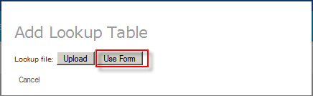

- Select the doForms data table to use
- Select “Update Automatically” if you wish to have the lookup table updated whenever the doForms data table changes (more on this below).

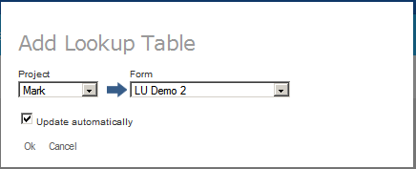

- Click Ok
- Type in a Description for this lookup table (optional).
- Click Save Table when done.

Updating a Lookup Table

To update a lookup table, click the Resources menu, then select Manage Lookup Tables. Click the Row Menu next to the lookup table you wish to delete and select Update.

If the lookup table was from an external Excel or CSV file, you will be asked to upload an updated CSV or Excel 97-2003 lookup file. For the update to work seamlessly, the updated files MUST have exactly the same number of columns and exactly the same column names (number of rows or actual data values in the rows can be different). If this is not the case, then we recommend deleting the saved lookup table and uploading the new one under a different name. You will also need to reset the properties of any lookup questions in your forms which utilize this lookup table.

If the lookup table was created from a doForms data table and you did NOT select the “Update Automatically” option, then you must use the procedure above to update the lookup table.

If the lookup table was created from a doForms data table and you DID select the “Update Automatically” option, then the lookup table will be updated whenever changes are made to the doForms data table (e.g. new data records are received, or edits are made in the View Data tab).

IMPORTANT: If an edit is made to the doForms data table in the View Data tab, then in order for the corresponding lookup table to be automatically updated, the user needs to log out of the doForms website and log back into the doForms Website. Alternatively, the user may use the procedure above to manually force and update without the need to logout and log back in.

Deleting a Lookup Table

To delete a lookup table, click the Resources menu, then select Manage Lookup Tables. Click the Row Menu next to the lookup table you wish to delete and select Delete.

Manage Excel Templates

In addition to the PDF report format described above, doForms allows you create Excel reports of your data. Excel reports have a number of advantages over PDF reports:

- Provide much greater control over format of the report
- Can apply Excel calculations and functions on your data
- Can include Excel charts and graphs generated from your data

Excel Reports are created using the notion of an Excel Template file. These template files are simply Excel worksheets that have been “Saved as …” an Excel Template. Note that doForms ONLY recognizes Excel 97-2003 and Excel 2010 Template formats (xlt, xltx, xltm).. See the View Data tab section for more information on how to create and use Excel Report Templates.
To manage your Excel Report Template, in the Build Forms tab click the Resources menu, then select Manage Excel Template. The dialog below will open with a list of all report templates that have been set up in the Build Forms tab.

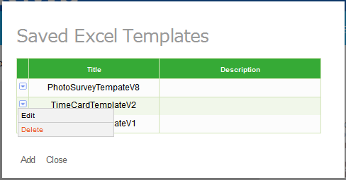

After the Excel Report Template has been created on your PC (see the View Data tab section), follow these steps up upload it to your doforms website:

- Go to the Build Forms tab of your website
- Click on the Resources menu
- Select Manage Excel Templates
- Click Add

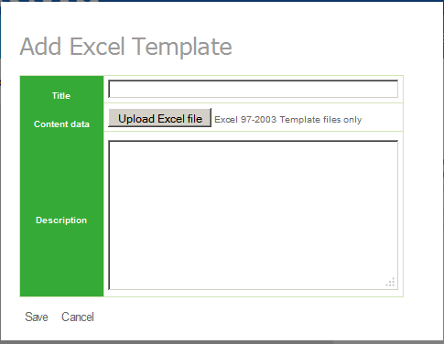

- Click Upload Excel File
- A “File Upload” dialog will open. Browse the files then select your Excel Report Template file and click Open

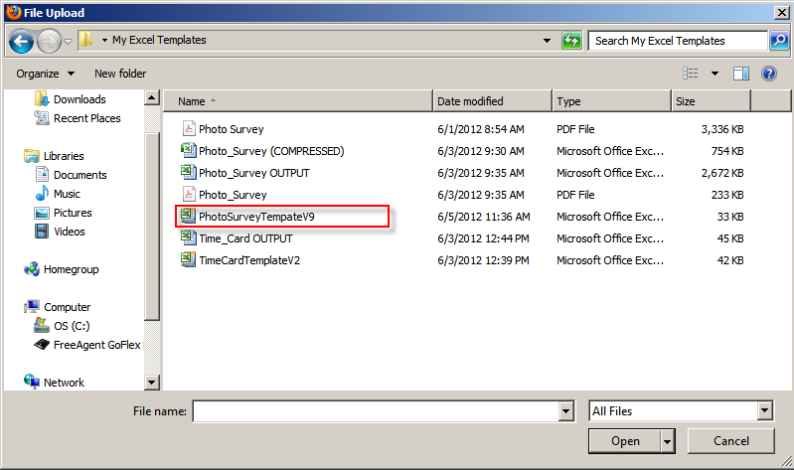

- Give your template a name and description, then click Save.

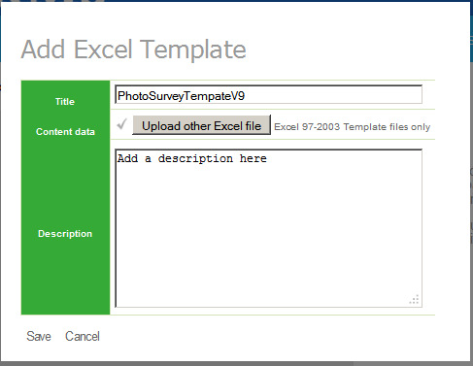

- Your template will be added to the Saved Excel Templates list
- Click Close

Repeat the steps above to load additional report templates into your Build Forms tab. Click Close when done.

See the View Data tab section for more information on how to create and use Excel Report Templates.
TIP: When you upload a report template, this template becomes available for use with any form in your account provided that the data names are exactly matching.

Adding, Moving, Duplicating & Deleting Questions

Adding a Question – There are two ways to add a question to the canvas: (i) click the desired question type at the bottom of the page and it will be appended to the form, or (ii) use a “drag and drop” motion to place the question anywhere on the canvas..

Moving a Question – To move the position of a question, use a “drag and drop” motion to place the question anywhere on the canvas.

Duplicating a Question – To duplicate a question, click on the duplicate icon in the upper right corner of the question canvas. This is very handy when creating a form with a list of similar questions.

Deleting a Question – To delete a question, click on the delete icon (trash can) in the upper right corner of the question canvas. You will be asked to confirm the delete.

IMPORTANT: The “drag and drop” motion is only supported by the newest versions of most popular web browsers. Please make sure your browser is up-to-date for the best experience in the Build Forms tab.

Question Widget Types

doForms provides the following question widget types which can be used sequentially, looped using a repeatable section, or connected using sophisticated skip and relevance logic. Each question type contains properties which allow you to customize the question and the way it works (discussed in the next section). In addition to the possible data fields below, each form is stamped with a date, time and device ID whenever the form data is saved in the mobile device.

Action Button – [paid accounts only – tablet UI only] The Action Button widget allows you to make your forms more “app like”. You can use a standard button format or upload your own customized button images. Action buttons can be used to jump to questions or pages, so you can build your own form/app menus. Action buttons can also be used to open web pages, play videos, launch other apps, or send customized dispatch status flags.

Approval – [paid accounts only] A special question type that can be inserted into one or more places within a form. These approvals are not displayed in the doForms mobile app, but they are displayed in the View Data tab. The approval status can then be changed by the responsible Web User, and the data record is “stamped” with that specific Web User’s login ID. This stamp cannot be edited and serves as a digital signature.

Audio – [paid accounts only] Allows the collection of audio input in the form using the device’s audio recorder. The format of audio files will depend on the mobile device.

Barcode – [paid accounts only] Allows the collection of barcode input using the device’s camera. Supported barcode formats include UPC-A and UPC-E; EAN-8 and EAN-13; Code 39, 93, 128; QR Code; ITF; Codabar, RSS-14 all variants; Data Matrix; PDF 417 alpha quality; Aztec alpha quality.

Calculation – [paid accounts only] The calculation widget allows you to perform arithmetic (= + - / * % Sum) operations on one or more previously entered numeric question values in the form. The calculation widget can also be used with date:time values (subtract one date:time from another to produce a decimal-hours difference; or add/subtract decimal-hours from a date:time to produce a new date:time). The result of a date:time calculation will always be stored as a decimal-hour value. See the “Using Calculations” section below for more information about creating calculations.

Choose-one – Allows the selection of one answer from a multiple choice list. Note that choose-one questions can be used inside a Questionnaire container to organize the questions in a tabular format.

Date:Time – Allows the selection of a date, time or date:time. You may use the “today” keyword when setting the “default” property for dates. When displayed in the mobile app, the date:time control also provides a Now button.

Email Report – [paid accounts only] Emails the competed form as a PDF report to one or more recipients in addition to sending it to your doForms website. The email is sent automatically when the completed form is sent and received by your doForms website. You can use the “Default” property to pre-populate email addresses. Use commas to separate multiple email addresses. See the “Emailing PDF Reports” section below for more detailed information.

Grid – [paid accounts only] A grid is a “container” for label, text, lookup, numeric and image question types. A fixed number of columns must be specified in the properties area. Questions placed inside the container are placed in the grid in a zig-zag pattern with each new line starting after the specified number of columns. See the “Using Grids” section below for more detailed information. Grids are similar to Tables except that in a Table the contents of each row are repeated (the columns differ). Whereas, the contents of cells in a grid can be completely random.

Image – [paid accounts only] Allows the collection of still images in the form, using the device camera. Previously taken images can also be selected and included in the form. The mobile app also allows the user to sketch atop the image to point out items of interest. Image files will be saved as JPEG format. There is no technical upper limit on the number of image files that can be inserted into a single form, however there is an upper limit of 35MB total for all the pictures in a form. Past this limit, the doForms application will begin running very slowly and may freeze. You can avoid this by restricting the number of pictures in a single form, and/or training your users to use a lower camera resolution when taking pictures. Camera resolution options vary by device, so please refer to your device user manual.

Label – Allows the entry of a section or heading label to help organize your form. Use the Caption text to provide a title or heading. Use the Hint property to provide additional information (e.g., instructions, warnings, etc.). Labels may also contain uploaded images. You can use this feature to “brand” a form with a logo, or to provide your mobile users with reference images. Also, in the "properties" for this widget you can control whether or not the label will be displayed in mobile app and/or PDF reports. You can force line breaks in the "Hints" section of a Label question by inserting a <br> tag

Location – Allows the collection of GPS map coordinates at the current location. The data will include latitude and longitude, and may include altitude and accuracy (depending on the mobile device).

Lookup – [paid accounts only] Lookup tables allow you to search on and select an answer from an external data table (Excel 2003 and CSV files only). Additionally, if a lookup table row contains answers for other questions in your form, you can use the table to automatically answer these questions as well. For example, if your form contains questions for entering “Customer Name”, “Customer Number” and “Customer Address”, and if you have a lookup table that also contains these columns, then you can set up “Customer Name” as the Lookup Table, and when the mobile user searched on and selects a Customer Name, the corresponding Customer Number and Number Address will be automatically filled out in the form. See the “Using Lookup Tables” section below for more information about working with lookup tables.

NFC – [paid accounts only] Allows the collection of Near Field Computing (NFC) tag values. Note that the type of tags supported is a function of the NFC sensor in the mobile device hardware (if any).

Numeric – Allows the entry of numbers only. You can specify Integer or Decimal in the properties. We recommend using numeric integer input for telephone numbers. On most mobile devices doForms will display a number pad for entering numeric values.

Page Break – Inserts a page break. These page breaks affect the “Form View” on tablet devices only. Within a page you can navigate Form View by swiping the screen vertically. To navigate between pages in Form View, swipe the screen horizontally or tap on the page bar at the bottom of the Form View screen.

Questionnaire - [paid accounts only – tablet UI only] A Questionnaire is a grid format “container” for score, choose-one, or select multiple question types (but you cannot mix question types in a questionnaire container). The answer options MUST be the same for all of the score, choose-one, or select multiple questions dragged into the questionnaire container. Questionnaire grids can have up to 10 columns, but an unlimited number of rows. The questions are listed in the first column of the grid. The answer values comprise the column headings.

Repeatable Section – [paid accounts only] A repeatable section is a “container” for one or more of any of the questions above. A repeatable section loops through the questions it contains. A maximum number of loops can be specified in the properties area. Note that mobile users will be prompted before each loop if they wish to continue. See the “Using Repeatable Sections” section below for more detailed information.

Score – [paid accounts only] Use for organizing choose-one questions into "score categories". For example, you may have one category of question that relate to the “appearance” of an item, and a second category related to the “smell” of an item, and a third category related to “taste”. This question type also automatically calculates and summarizes the total possible score for each category, total given score, and percent of given divided by possible. These summaries are displayed in the mobile app when the form is completed. They are also automatically added to the View Data tab. Note that score questions can be used inside a Questionnaire container to organize the questions in a tabular format.

Select Multiple – Allows the selection of multiple answers from a multiple choice list. Note that select multiple questions can be used inside a Questionnaire container to organize the questions in a tabular format.

Signature – Allows the collection of a signature using the touch-screen. Signatures are saved as raster images (JPEG). Note that signature questions will be ignored on non-touch screen devices, however, each submitted form is stamped with the Mobile Device number “system field”. Depending on your specific need this stamp may serve as “digital signature”.

Sketch – Allows the collection of touch-screen drawing input. Sketches are saved as raster images (JPEG). Note that sketch questions will be ignored on non-touch screen devices.

Table – [paid accounts only] A table is a spreadsheet like “container” for text, lookup, numeric, date:time, and calculation question types. Tables can have up to 10 columns. A fixed number of rows must be specified in the properties area. Tables are similar to Grids except that in a Table the contents of each row are repeated (the columns differ). Whereas, the contents of cells in a grid can be completely random. See the “Using Tables” section below for more detailed information.

Text – Allows the entry of alpha numeric information into a text entry box. The box will expand in size as more text is entered. Text boxes are the most generic data entry format. On most mobile devices doForms will display a keyboard for entering text.

Video – [paid accounts only] Allows the collection of video w/audio input in the form. Note that video clips have a 5 second limit. The format of video files will depend on the mobile device.

IMPORTANT: Note that if a mobile device’s hardware does not support a question type, then the question will be automatically skipped by the doForm mobile app. For example, if the device does not have GPS (or the GPS is not enabled) all Location questions will be automatically skipped. In these cases the value “no_gps” will be coded as the answer to the questions. Other possibilities include “no_media” in the case that a camera or microphone are not present, “no_draw” in the case that there is no touch-screen drawing surface, and “no-barcode” in the case that there is no camera or barcode driver. When designing your form, consider providing alternate input methods for these cases by using “relevance” logic. For example, if the value returned is “no_gps”, then use relevance logic to trigger a text question that asks the user to enter an address or description of the location.

Basic Properties

Action – [action button] Allows you to select the type of action that will take place when the action button is pressed. Action options are (1) jump to question, (2) jump to pages, (3) open web page, (4) play video, (5) launch another app, (6) send customized dispatch status flag, or (7) save and send the form.

Action button text – [action button] Allows you specify the text that will be displayed in a standard button format. If you use an image instead of the standard button format, the image will need to contain any desired text.

Allow image to be selected – [image] Allows a previously taken image to be selected and included in the form.

Android app name – [action button] Used when the Action property is set to “Launch Program” to specify the name of the Android app that will be launched when the action button is pressed. For Android devices the “app name” must be spelled exactly as listed in the device Settings > Manage Applications page.

Append comment field – [questionnaire] Check if you wish to append a special text comment field as the last column in a Questionnaire container.

Automatically return to form view at the end of page – [page] If selected this option will automatically return doForms to Form View when the user completes the last question on the page in Question View. This option is handy for letting users review their work after completing the page.

Auto-stamp – [location, date:time] Use this property for automatically inserting GPS or data:time stamps inside a form. For example, you can insert Date:Time auto-stamps at the beginning and end of a form to calculate how long it takes to complete the form. When using the Location Auto-stamp, be sure to choose your GPS minimum error and maximum error “Range” values carefully. In most cases these should be set to 50 meters and 300 meters respectively to ensure that the auto-stamp function can occur quickly with minimum delay for the mobile user.

Caption/label text – [all question types] The question caption as presented to the user. Think of this as the title for the question. It should be self descriptive. We recommend no more than three words for optimal display on mobile devices. Note that for repeatable sections this is called a Section Label. We suggest experimenting on your mobile device with section labels in context with “loop” prompts in repeatable sections. The maximum number of characters is 500, including spaces.

Category – [score] Specifies the score category that the answer to a score question will be assigned. Score questions automatically calculate and summarize the total possible score for each category, the total given score, and the percent of given divided by possible.

Choose-one destination field – [lookup] Check if you would like to compare the lookup table value with the “underlying_value” property for choose-one “destination questions”. Otherwise the lookup table value will be compared with the “Answer as displayed to the user” choose-one property of the choose-one “destination questions” When the values are the same, that answer option in the choose-one answer option will be selected. For example, supposed your form has a choose-one question with the following answer options:

Answer as displayed to the user Underlying_value
YES 1
NO 0

In this case if your lookup table had YES/NO answers you would NOT check the “Choose One Destination Fields” option. But if your lookup table had 1/0 answers you WOULD check the “Choose One Destination Fields” option.

Column spacing – [table, questionnaire] Specifies if columns will be evenly spaced (if checked) or variable width (if unchecked). The width or variable width columns will be determined by the length of their Caption property.

Currency symbol – [numeric, calculation] Places a currency symbol in front of the value. Note that these symbols are for display and PDF report purposes only. The currency symbol is not exported to Excel, CSV or other “Save as” formats. The currency also is not exported via web services or Sync & Save.

Data name – [all question types] The name of the data that will be displayed in column headings. This property is automatically filled in based on the Caption Text but may be modified in the properties area. We recommend one or two word data names to keep column headings short. The maximum number of characters is 30. Spaces are not permitted in the Data Name field. Note that for Repeatable Sections or Tables, the data name in each repeat or row will be followed by “(#)”. So for example, if the data name of a question is “price” then the data names of the corresponding repeats or table rows will be price(1), price (2), price(3) etc. In nested repeatable sections the format will be “data_name(#,#)”. Note that the value “data” is reserved by the system and cannot be used as a data_name in your forms.

Data source – [lookup] Selects the lookup table to be used. In the example below we are using the “Customer List” lookup table.

Decimal place – [calculation] Number of decimal places displayed for the value of a calculation.

Default value – [text, numeric, date, choose-one, select multiple, location, barcode] The value of the field first presented to the user when they see the question. Unless the question is marked as “Read Only” the mobile user will be able to change the value. This is very useful where the answer to a question is likely to repeat itself over and over. Setting a default value minimizes the work for mobile users. Note that repeating values can also be set on the mobile app using the “Remember Answer” option.

Destination fields – [lookup] Provides a “mapping” of any additional lookup table fields that will be used to populate other question fields in your form. In the example below, we are going to use the “Name Last” field in the lookup table to populate the “Last_Name” field in the form, “Name First” field in the lookup table to populate the “First_Name” field in the form, “Address” field in the lookup table to populate the “Address” field in the form.

Destination page – [action button] Used with the “Jump to page” action to specify the form page to jump to when the action button is pressed. The “Execute auto stamp …” option determines whether or not to execute any date:time or location autostamp questions located between the action button and the destination page.

Destination question – [action button] Used with the “Jump to question” action to specify the question to jump to when the action button is pressed. The “Execute auto stamp …” option determines whether or not to execute any date:time or location autostamp questions located between the action button and the destination question.

Display the capture barcode button – [lookup] If checked the mobile app will include a Barcode scanning control in the question widget. This is handy if your “Lookup Field” is a barcode.

Display time values as hh:mm – [calculations] If checked the mobile app will display the results of date:time calculations in hh:mm format. Note however, that the actual values will be saved in decimal-hour format.

Equally spaced columns – [table, grid] Causes the width of columns to be equally spaced. If not checked, the widths of the individual columns will be based on the length of the caption text.

Expression – [calculation] A arithmetic expression made of “Operators” and “Fields”. Operators include = + - * / . Fields are the data_name of a numeric field, or the Sum or Count of a numeric field inside a preceding repeatable section.

Evaluate blank (null) condition values – [lookup] Causes lookup conditions to evaluate null (blank) condition values. Otherwise, null (blank) condition values will be ignored. Use this if one or more steps in a set of sequential lookup conditions need to be evaluated as being “null” rather than just skipped if left blank. This option is important in optimizing the performance of the lookup widget when null values are a possibility.

Hide field in website – [text, numeric, date:time, calculation, label, location] Controls whether the value generated by the widget will be displayed in the website. Allows you to store data in a field but not display the field in the website. Commonly used to trigger relevance or skip logic conditions and also used in calculations.

Hide field in mobile app – [text, numeric, date:time, calculation, location] Controls whether the widget will be displayed in the mobile app. Allows you to store data in a field but not display the field in the mobile app. Commonly used to trigger relevance or skip logic conditions and also used in calculations.

Hide in reports – [label] Controls whether the value generated by the widget will be displayed in reports. The property is handy for storing temporary values that will be used by other widgets.

Hide rows – [table] This option is used in conjunction with the “Used Checklist” option. Use this option to hide rows that contain a specified alpha-numeric value. When checked an entry box will be displayed where you can enter an alpha-numeric “hide_flag” or leave blank if you want a blank/null value to be the hide_flag.

Hint – [all question types except repeatable section] Additional help for the question will be displayed.. Short clear sentences work best. Use 80 characters or less for optimal display on mobile devices. The maximum number of characters is 500, including spaces. The following HTML formatting tags are currently recognized:
Android: <br>, <i>, <b>, <u>, <font color="xxx">, <H1>, <H2>, <H3>, <H4>, <H5>, <P>, <a>, <div>
iOS: <br>
PDF reports: <br>, <font color="xxx">
Image justification – [label, action button] Controls the justification of the button (left, center, right).

iOS app URL scheme – [action button] Used when the Action property is set to “Launch Program” to specify the ID of the iOS app that will be launched when the action button is pressed. iOS app URL scheme forms in most apps can be found at http://handleopenurl.com (see the Using Action Buttons section below for more information).

Kind – [date:time, lookup, calculation] Specifies the type of value used in the date:time widget, lookup widget or calculation widget. For date:tme widget the kind of field can be date, time, or date:time. For lookup widget the kind of value can be Number or Text. For calculation widget the kind of value can be Number or Date:Time.

Length – [text, numeric, barcode, NFC] Validates the character length of the user input in terms of a minimum and a maximum number of permitted characters (spaces are counted).

Limit to list – [lookup] Limits the entry of data to a lookup table selection only. If the lookup has any destination questions, the answers to these questions will also be limited to the corresponding values in the lookup table.

Lookup conditions – [lookup] Specifies if any prior lookup selection (from the same lookup table) will be used to filter the lookup field. For example, if you have a lookup table with state and city columns, you could setup one lookup question to select the state, and a second lookup question to select the city. A lookup condition can also be specified as the answer value to a prior text, numeric or choose-one question.

Lookup field – [lookup] Select the field in the lookup table that will be used in the lookup search/list. In the example below we are using the “Customer Number” field in the lookup table.

Max repeats – [repeatable section] This is the maximum number of loops for the repeatable section. Default value is 10. The maximum number that can be entered is 20. Note that mobile users will be prompted before each loop if they wish to continue (see Repeat Transition Text property). Therefore, the actual number of loops performed will be controlled by the mobile user.

Military time – [date:time] If checked, the time portion of a date:time will be in 24-hour military time. Otherwise it will be 12 hour time with an AM/PM option.

Number columns – [grid] Specifies the number of columns in the Grid container.

Number rows – [table] Specifies the number of rows in the Table container.

Number type – [numeric] Integer or Decimal. Specifies whether the input number may contain a decimal point.

Options – [select multiple, choose-one, score] Specifies the values of the multiple choice answers. Each option includes an “answer name as presented to the user” and an “underlying value”. Underlying values can be descriptive or alpha-numeric codes of your choosing. Although spaces are permitted, its best to use underscores. The maximum number of characters for “answer name” is 500, including spaces. The maximum number of characters for “underlying value” is 500. Spaces are not permitted in the “underlying value” field.

Page name – [page] Used to specify a short text string that will be displayed as a page name in the page navigation bar at the bottom of Page View. If a page name is not specified, then sequential numbers will be used for navigation in the page navigation bar at the bottom of Page View.

Range – [numeric, date:time, location] Validates the input data in terms of a minimum and a maximum value. For location questions, the minimum error is the GPS accuracy at which the GPS widget stops trying to refine the accuracy; and the maximum is the largest permitted GPS error.

Read only – [text, numeric, date, choose one, select multiple, location, media, draw, barcode, NFC] Determines whether or not this field can be edited.. This is used in combination with a Default Value.

Repeat transition text – [repeatable section] Transition text that will be displayed at the end of each repeatable section loop to instruct the mobile user what to do next (300 characters maximum).

Required – [text, numeric, date, choose one, select multiple, location, media, draw, barcode, NFC] Determines whether or not this field must be filled-in before continuing to the next question. On the mobile device, a form with an empty required field may be saved as “incomplete” but not as “complete” and hence cannot be sent to your website.

Sort lookup list alpha-numerically – [lookup] Check this if you want to sort your lookup field alpha-numerically. Numbers are sorted first, followed by letters. If you wish to avoid sorting results like 1, 2, 3 …..8, 9 then pad number values with leading zeros 01, 02, 03 … 08, 09, 10, 11.

Status text – [action button] Used with the “Send Status” action to specify the text string that will be sent to the Dispatch tab as a status message. Note that an internet connection is required for sending a status message.

Underlying value – [score] Specifies the numeric score value that will be assigned to the “answer name as presented to the user” property. So for example, the answer “good” may have an underlying value of “5”. Only numeric (integer and decimal) underlying values are counted in the score summary arithmetic. Non-number underlying values (e.g., “na” or “not_applicable”) are NOT counted the score arithmetic and summaries.

Upload image – [label] Allows you to upload an image to be displayed. There is no restriction on the size of the image. Accepted image formats are JPG and PNG.

URL of video – [action button] Used with the “Play Video” action to specify the website URL of the video to be played. Note that an internet connection is required for playing videos.

URL of web page – [action button] Used with the “Open Web Page” action to specify the website URL of the web page to be opened. Note that an internet connection is required for opening a web page.

Use as input for conditional lookups only – [lookup] Check this if option to improve speed in this widget is being used only to support conditional lookups later in your form. Uncheck if you want full lookup functionality

Use checklist – [table] Use this option if the first question in the Table is a Lookup and you wish to display all the rows in a checklist format. Be sure the "Number Rows" value above equals or exceeds the number of rows in the Lookup table.

Use image – [action button] Allows you to upload a custom button image to be used as a button (as an alternative to a standard doForms button shape). There is no restriction on the size of the image. If you want your custom buttons to have text, then this text needs to be embedded in the image prior to upload. Accepted image formats are JPG and PNG.

Use lookup in website Dispatch tab only – [lookup] Use the display the lookup in the website Dispatch tab only. This property is used when you wish to use a lookup to pre-populate a dispatched record on the website prior to sending, but do not wish to send the lookup table to the mobile devices.

Advanced Properties (Paid Account Only)

The “advanced” area provides “skip” and “relevance” options which can be used for applying very sophisticated logic to the behavior of your doForm.

Adding Skip Logic

You can apply skip logic to jump from one question to any other question below it (or to the end of the form). This is done by evaluating the answer to the original question based on a condition and then jumping to the destination question if that condition is met.

In the example below, the skip condition can be interpreted as “skip to the end of the form if the answer to the current question is A”.

You may also use “compound” skip logic to evaluate two or more skip conditions using AND / OR logical operators (see section below).

Note that you cannot use skip logic to create loops. Use Repeatable Sections for looping.
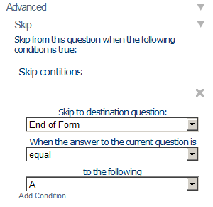

IMPORTANT: Skip logic is automatically cleared whenever the properties of any of the questions involved are altered. For this reason, we recommend adding skip logic last and always checking it prior to saving a form as Published.

Adding Relevance Logic

You can apply relevance logic to ignore a question based on the answer to any question above it. This is done by evaluating the answer to the prior question based on a condition and ignoring the current question if that condition is not met.

In the example below, the relevance condition can be interpreted as “if the answer to the media image capture question above was ‘no_media’ then display the current sketch question.” Otherwise the current sketch question would be ignored.

The example below also illustrates how relevance logic can be used to make robust forms that contain alternative questions when a certain type of hardware input is not available. In this example, if the mobile device does not possess a camera, the previous image capture question would have been skipped over automatically, and the value “no_media” assigned to that image capture question would have been used to trigger the current sketch question as an alternative.

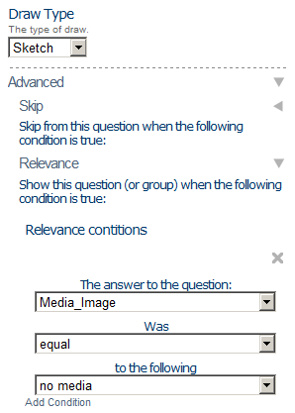

Another useful tactic is to use the “not equal” operator with a “blank” answer value. The example below would cause the relevance logic to trigger if any one of the answers to the select multiple question is checked. The alternative for achieving this result would be to use the “equal” operator in multiple compound logic statements (see next section).

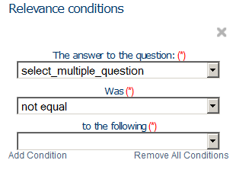

You may also use “compound” relevance logic to evaluate two or more relevance conditions using AND / OR logical operators (see section below).

IMPORTANT: Relevance logic is automatically cleared whenever the properties of any of the questions involved are altered. For this reason, we recommend adding relevance logic last and always checking it prior to saving a form as Published.

Compound Logic

Both the Skip Logic and Relevance Logic features provide the ability to use multiple logical conditions. As an example, supposed you have building inspection form with the following Select Multiple question:

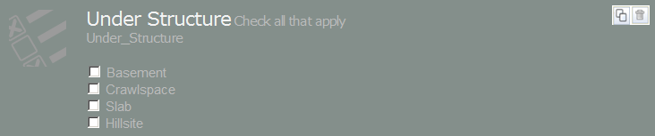

Furthermore, in a situation where both Basement and Crawlspace are selected you would like Numeric Question to be displayed where you can enter the percent that is basement.

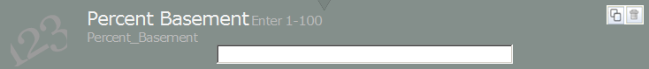

Then you might use the compound relevance logic below to specify that the Percent Basement question will only be displayed if Basement and Crawlspace are checked above:

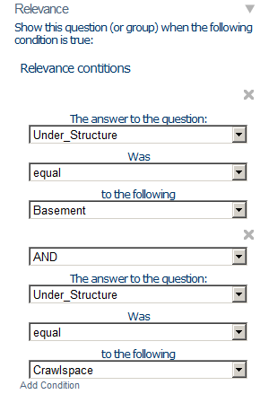

Applying compound logic can be a little bit tricky. Logical operators are evaluated from left to right, and in the following order:

- Evaluate all “less than” and “greater than”, next
- Evaluate all “equals to”, next
- Evaluate all logical “AND”, next
- Evaluate all logical “OR”, next

Below are a few examples which illustrate how certain compound conditions will be interpreted in the doForms mobile app:

Compound Condition:
Under_Structure is equal “Basement” AND Under_Structure is equal “Crawlspace”.
Result:
If Under_Structure = “Basement” only => Percent_Basement is not displayed
If Under_Structure = “Basement” & “Crawlspace” => Percent_Basement is displayed
If Under_Structure = “Basement” & “Crawlspace” & “Slab” => Percent_Basement is displayed
If Under_Structure = “Basement” & “Crawlspace” & “Slab” & “Hillside” => Percent_Basement is displayed
If Under_Structure = “Basement” & “Slab” => Percent_Basement is not displayed
If Under_Structure = “Basement” & “Hillside” => Percent_Basement is not displayed

Compound Condition:
Under_Structure is equal “Basement” AND Under_Structure is equal “Crawlspace” OR Under_Structure is equal “Slab”
Result:
If Under_Structure = “Basement” only => Percent_Basement is not displayed
If Under_Structure = “Basement” & “Crawlspace” => Percent_Basement is displayed
If Under_Structure = “Slab” => Percent_Basement is displayed
If Under_Structure = “Basement” & “Slab” => Percent_Basement is displayed
If Under_Structure = “Basement” & “Hillside” => Percent_Basement is not displayed
If Under_Structure = “Basement” & “Slab” & “Hillside” => Percent_Basement is displayed.

Compound Condition:
Under_Structure is equal “Basement” AND Under_Structure is equal “Crawlspace” OR Under_Structure is equal “Slab” OR Under_Structure is equal “Hillside”
Result:
If Under_Structure = “Basement” only => Percent_Basement is not displayed
If Under_Structure = “Basement” & “Crawlspace” => Percent_Basement is displayed
If Under_Structure = “Basement” & “Slab” => Percent_Basement is displayed
If Under_Structure = “Basement” & “Hillside” => Percent_Basement is displayed
If Under_Structure = “Slab” => Percent_Basement is displayed
If Under_Structure = “Hillside” => Percent_Basement is displayed
If Under_Structure = “Slab” & “Hillside” => Percent_Basement is displayed

Tips:
Consider using the “Hide field in mobile app” property in special text, numeric, date:time and calculation questions to store data values that can be used to trigger relevance or skip logic conditions.

Using Page Breaks

Page Breaks are used to organize long forms into pages that can be easily navigated in “Form View on [tablet devices only]. To insert a page break into your form simply drag it where you want the page to begin (including at the top of your form to delineate the first page). Page Breaks have the following special properties:

Page name – Used to specify a short text string that will be displayed as a page name in the page navigation bar at the bottom of Page View. If a page name is not specified, then sequential numbers will be used for navigation in the page navigation bar at the bottom of Page View.

Automatically return to form view at the end of page – Selecting this option will automatically return doForms to Form View when the user completes the last question on the page in Question View. This option is handy for letting users review their work after completing the page.

The illustration below shows a form that has been organized with into five pages (Main, Time, Score1, Score2, Email). Score2 is the page currently being shown. Within a page you can navigate Form View by swiping the screen vertically. To navigate between pages in Form View, swipe the screen horizontally, or tap on the page bar at the bottom of the Form View screen.

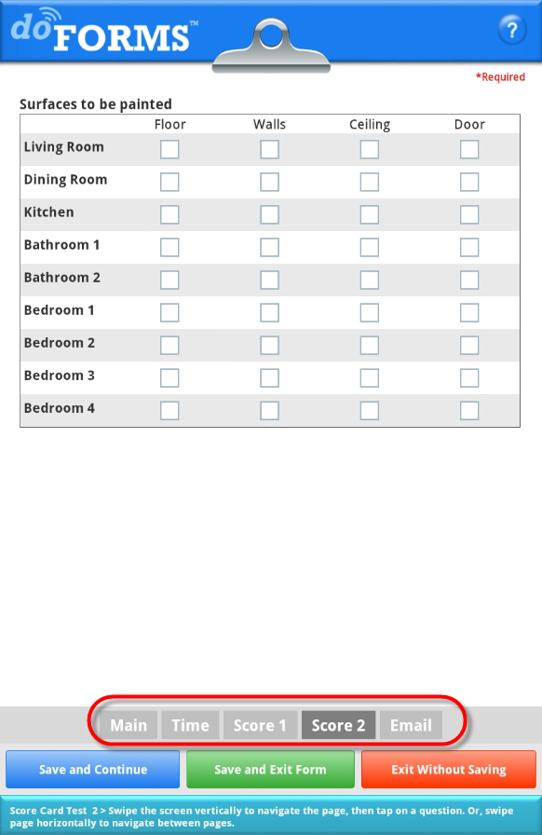

Using Repeatable Sections (Paid Account Only)

A repeatable section is a “container” for one or more of any doForms questions widgets. A repeatable section loops through the questions it contains. A maximum number of loops can be specified in the properties area (default is 10). In the doForms mobile app, users will be prompted before each loop if they wish to continue. Therefore, the actual number of loops performed will be controlled by the mobile user.

Note that repeatable sections can be “nested” within one another. Nested repeatable sections provide a very efficient way to enter long lists of information; for example, an inventory of part numbers (inner loop) located on a particular shelving unit in a warehouse which contains multiple shelving units (outer loop).

To create a repeatable section, drag and drop the Repeatable Section question widget on the Form Canvas. Next, drag and drop the desired question widgets into the repeatable section. Be sure to specify the Max Repeats property.

We strongly suggest experimenting with the Section Label property in context with the “loop” prompts on the mobile device. A clever choice of words can result in a very smooth user interface. But the only way to preview and test this is on a mobile device.

Additionally, Repeatable Section widgets have a special “Repeat Transition Text” property. You can use this property to specify which transition text will be displayed at the end of each repeatable section loop to instruct the mobile user what to do next (300 characters maximum).

In the example below, we’ve created a repeatable section for entering a list of parts and calculating Quantity x Unit Price subtotals.

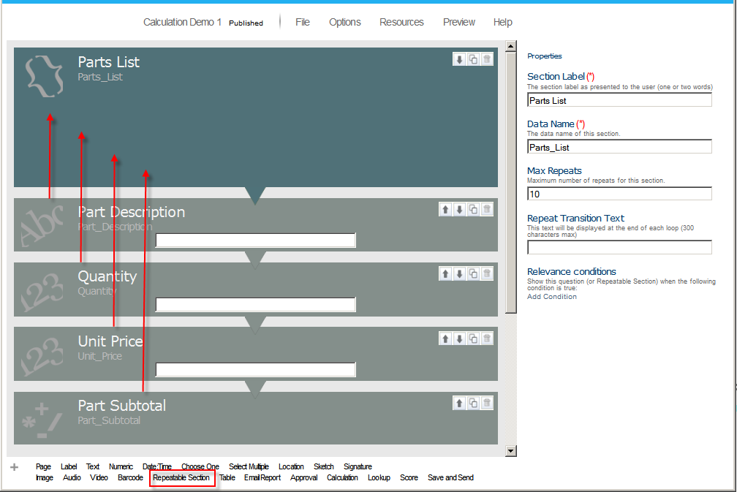

Using Calculations (Paid Account Only)

The calculation widget allows you to perform arithmetic (= + - / * ) operations on one or more previously entered Numeric question values in the form. The result of the arithmetic expression is stored in the calculation field.

In the example below, we have created a repeatable section for entering a list of parts used in a particular task. Each part has a Part Description, Quality and Unit Price. The calculation widget is used to calculate Quality x Unit Price for each part.

The Decimal Place property is used indicate how many decimal places should be displayed (not that the actual value is not rounded off).

The Expression property is used to build the formula based on previously entered number values. Note that the calculation widget needs to be placed after any question fields that will be used in the calculation.

In the simple invoice example below we calculate the item price (=unit price x quantity) of every item entered into the repeatable section.

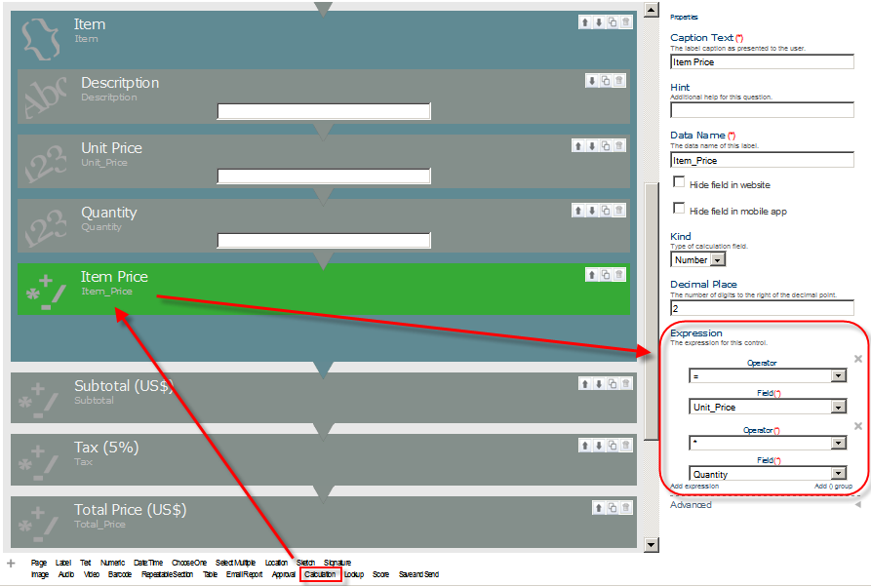

Sum and Count of a Repeatable Section

If your form contains a repeatable section you can use Sum and Count functions in your calculations to sum up all the values entered into a preceding repeated numeric field (e.g., to calculate a total) or to count the number of times data was entered into a field (e.g., for division of the total to calculate an average)

As an example, in the invoice above we can Sum the value of all the Item_Price calculations to get a subtotal.

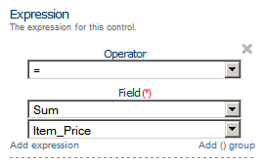

We can then multiple the subtotal times a tax rate (a constant) to calculate the sales tax

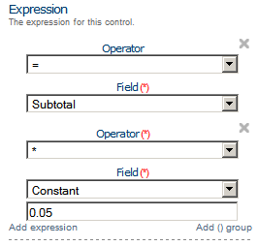

And finally add the Subtotal and Sales tax to get a Total Price

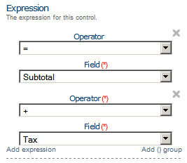

If we want to get a count of the number of items ordered (i.e., number of Item_Price fields that were calculated) we can use the Count function which works the same way as the Sum function but returns an integer count.

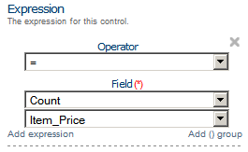

Parenthesis ( ) Group

In other circumstances you might consider using a parenthesis ( ) group to organize a complicated expression. If needed you can nest parenthesis within parenthesis. The example below shows an alternative way to calculate the Total_Price without explicitly calculating a subtotal and tax as done above.

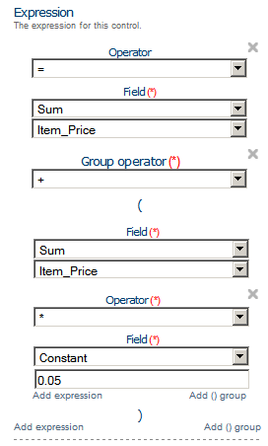

Use of Hidden Fields for Variables

In other circumstances you might consider using the “Hide field in mobile app” property in numeric questions and calculations to store data values which you do not want displayed to the user. As an example, suppose you wanted to pass a tax rate to the form above. You could create a numeric field called “Tax_Rate”. By making the field hidden it would not be explicitly displayed in the form, but could still be used in the tax calculation above. Hidden fields are also handy for very complex calculations that you want to do in parts.

Date:Time Calculations

The calculation widget can also be used with date:time values. The possible operations are (1) subtract date:time1 from date:time2 to produce a difference in decimal-hours; or (2) add/subtract decimal-hours from date:time1 to produce a new date:time2. Be sure that you correctly set the “Kind” property to date:time if performing calculations that involve a date:time (even when the result will be a numeric value). When using the “Sum” operator to sum up a list of differences in decimal-hours be sure to set the Kind to number, as these differences are stored as numbers.

Display time values can be formatted as hh:mm in the mobile app by using the “Display time values as hh:mm” property. Note however, that the actual values will be saved as decimal-hours.

Using Scores (Paid Account Only)

The score widget allows you to perform calculate scores based on numeric underlying values for a special type of choose one question. Questions are grouped into categories. The score widget calculates and displays score possible total, score actual total, and percent actual of total for each category and for all categories.

In the example below there are four score questions in the form. The cleanliness and orderliness question are assigned to the “appearance” category. The temperature and humidity questions are assigned to the “climate” category. The numeric values for each answer choice are used in the score calculations.

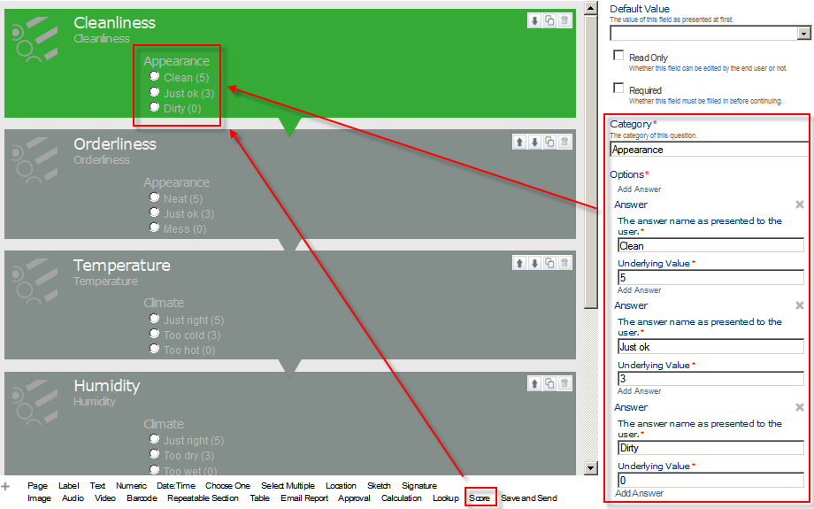

In the example below, the form is completed with the following values:

Cleanliness = Clean (5)
Orderliness = Just ok (3)
Temperature = Too cold (3)
Humidity = Too wet (3)

The calculated score values will be displayed at the end of the form, and will also be included in the View Data tab results.

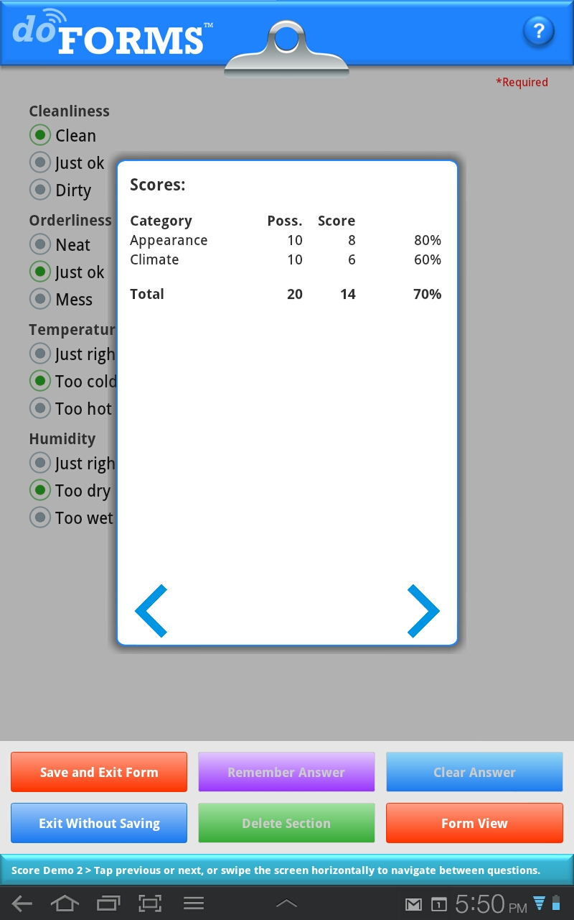

Using Questionnaires (Paid Account Only)
http://www.doforms.com/support/how-to-videos/how-to-questionnaire.htm

A Questionnaire is a table format “container” for score, choose-one, or select multiple question types. You can use this container to display the questions in a tabular format as illustrated below when in Page View. The question captions are listed in the first column of the table. The answer values comprise the column headings.

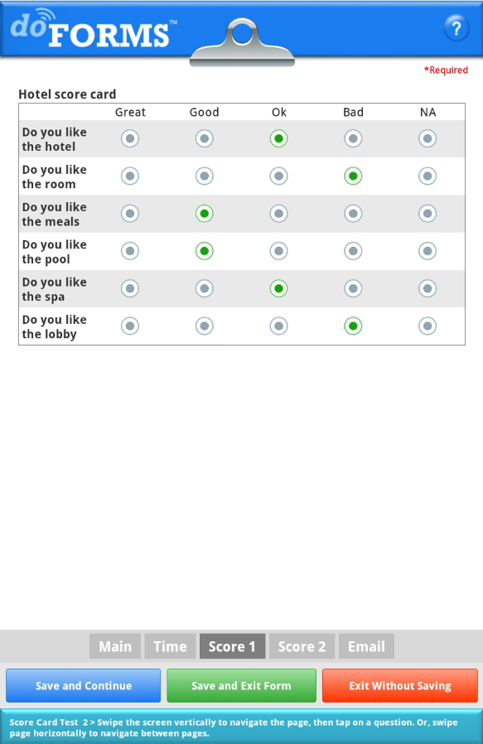

To set up the Questionnaire in your form, simply drag and drop the “Questionnaire” widget into the desired location in the question canvas as illustrated below. Then drag and drop up to score, choose-one, or select multiple questions into the Questionnaire. You can use the “Equally Spaced Columns” property to make columns an equal width as shown above. Otherwise the column width will be controlled by the length of the caption text of the question answers (i.e., the “The answer name as presented to the user” property of each answer option”.

A very useful trick when creating a Questionnaire is after adding the first question, use the “Duplicate” button to create the other questions. This saves you from having to redo all the answers (which have to be exactly the same). You only need to change the “Caption” property of each question. This technique will save time and reduce errors.
.

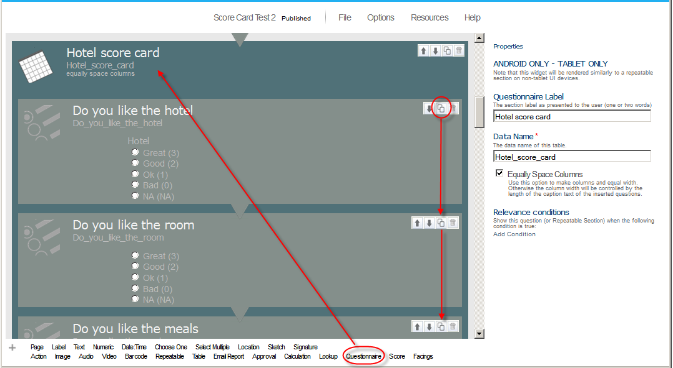

IMPORTANT:

- You may NOT mix question types in a questionnaire container. The questions need to be all of the same type (score, choose-one, or select multiple) .
- The answer options MUST be exactly the same for all the questions. This includes the “The answer name as presented to the user” and “Underlying value” properties.
- Questionnaires can have up to 10 columns but an unlimited number of rows.

Using Action Buttons (Paid Account Only)

http://www.doforms.com/support/how-to-videos/how-to-action-buttons.htm

The Action Button widget allows you to make your forms more “app like”. You do this by creating “buttons” then assigning actions to the buttons when pressed. Action buttons can be used to jump to questions or pages, so you can build your own form/app menus. Action buttons can also be used to open web pages, play videos, launch other apps, send customized dispatch status flags, or save and send a completed form with just one click.

Below is an example of a form which uses Action Buttons to create a menu that the mobile user can use to navigate the form. In this example, the Page break widget is used to create a first page in the form which only contains the menu.

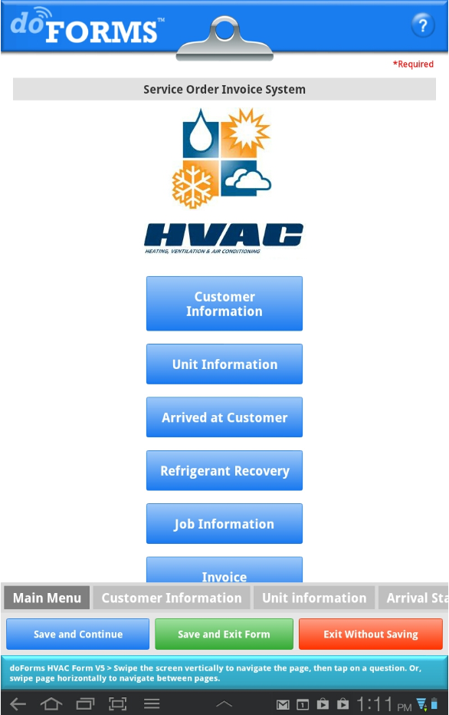

To create an Action Button drag the widget onto the question canvas of your form (illustrated below). If you are creating a menu, you will need one Action Button for each menu button. You can use our standard doForms buttons (as shown above and below), or upload your own customized button images for a more polished look. To upload your own customized button, just check the “Use image” property. If you want your custom buttons to have text, then this text needs to be embedded in the image prior to upload (while this is in a Label widget – the HVAC graphic above and below is an example of an uploaded image)..

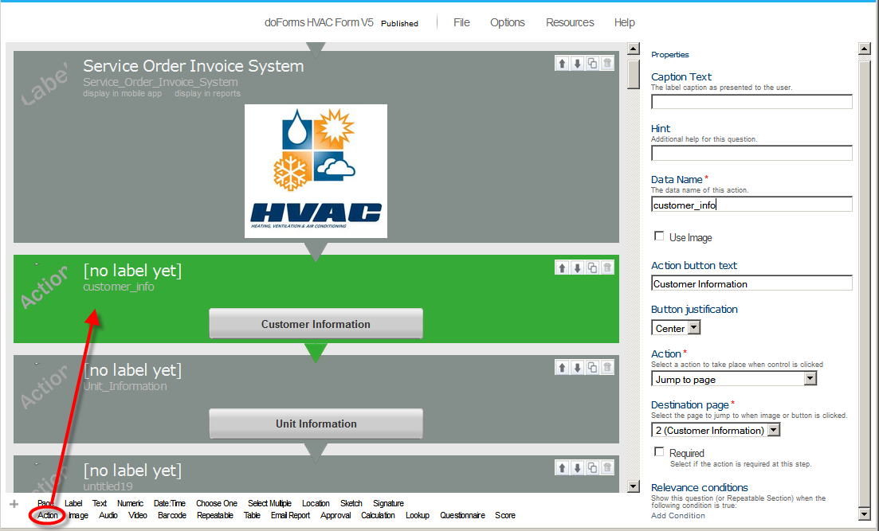

The Acton Button widget has the following special properties that you use to control its look and behavior:

Use image – Allows you to upload a custom button image to be used as a button (as an alternative to a standard doForms button shape). There is no restriction on the size of the image. If you want your custom buttons to have text, then this text needs to be embedded in the image prior to upload. Accepted image formats are JPG and PNG.

Image justification – Controls the justification of the button (left, center, right).

Action button text – Allows you specify the text that will be displayed in a standard button format. If you use an image instead of the standard button format, the image will need to contain any desired text.

Action – Allows you to select the type of action that will take place when the action button is pressed. Action options are (1) jump to question, (2) jump to pages, (3) open web page, (4) play video, (5) launch another app, (6) send customized dispatch status flag, or (7) save and send the form.

Destination page – Used with the “Jump to page” action to specify the form page to jump to when the action button is pressed. The “Execute auto stamp …” option determines whether or not to execute any date:time or location autostamp questions located between the action button and the destination page.

Destination question – Used with the “Jump to question” action to specify the question to jump to when the action button is pressed. The “Execute auto stamp …” option determines whether or not to execute any date:time or location autostamp questions located between the action button and the destination question.

URL of video – Used with the “Play Video” action to specify the website URL of the video to be played. Note that an internet connection is required for playing videos.

URL of web page – Used with the “Open Web Page” action to specify the website URL of the web page to be opened. Note that an internet connection is required for opening a web page.

Status text – Used with the “Send Status” action to specify the text string that will be sent to the Dispatch tab as a status message. Note that an internet connection is required for sending a status message.

Android app name – Used with the “Launch Program” action to specify the name of the Android app that will be launched when the action button is pressed. For Android devices the “app name” must be spelled exactly as listed in the device Settings > Manage Applications page.

iOS app URL scheme – [action button] Used when the Action property is set to “Launch Program” to specify the ID of the iOS app that will be launched when the action button is pressed. iOS app URL scheme forms in most apps can be found at http://handleopenurl.com. Below is a lookup result for Google Maps. The app URL scheme is “comgooglemaps” which is the value you would enter in the Action Button property.

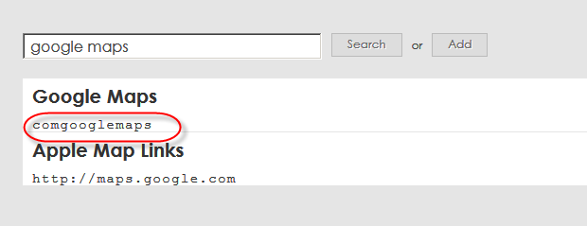

Additional Action Button Videos can be found at the following web page:

http://www.doforms.com/support#2

- How to Use Action Buttons to "Jump to a Page"
- How to Use Action Buttons to "Jump to a Question"
- How to Use Action Buttons to "Launch an External Application"
- How to Use Action Buttons to "Open a Web Page"
- How to Use Action Buttons to "Play a Video"
- How to Use Action Buttons to "Send a Dispatch Status Message"
- How to Use Action Buttons to "Save and Send a Form in One-click"

Using Lookups (Paid Account Only)

http://www.doforms.com/support/how-to-videos/how-to-create-a-simple-lookup.htm

Lookup tables allow you to search on and select an answer from an external data table. Additionally, if a lookup table row contains answers for other questions in your form, you can use the table to automatically answer these questions as well. For example, if your form contains questions for entering “Customer Number”, “Customer Name” and “Customer Address”, and if you have a lookup table that also contains these columns, then you can set up “Customer Number” as the Lookup Value, and when the mobile user searches on and selects a Customer Number, the corresponding Customer Name and Customer Address will be automatically filled out in the form.

The illustration below shows a simple lookup table CSV file.

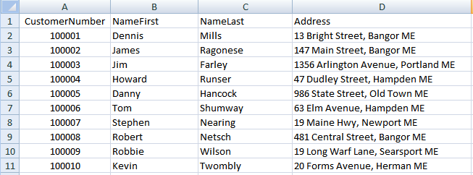

The Option Menu section above provides instruction on uploading lookup table files into the Build Forms tab. Once a lookup file is uploaded, it may be used in one or more forms as described below. External files must be CSV or Excel 2003 format, and the first row of the file must contain field names for each column (no spaces or special characters).

To see which lookup tables are available in your account, click the Options menu, and select Manage Lookup Tables. In the illustration below, the lookup table name “Customer List” contains the data above.

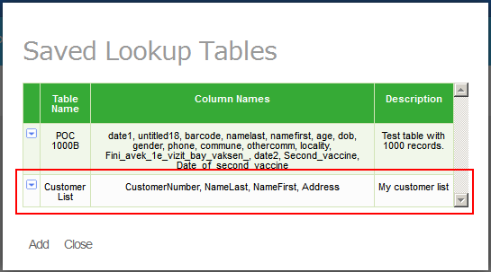

After you have confirmed that the desired lookup table has been uploaded, you are ready to set up a “lookup” question in your form.

To set up the lookup table in your form, simply drag and drop the “Lookup” question widget into the desired location in the question canvas as illustrated below.

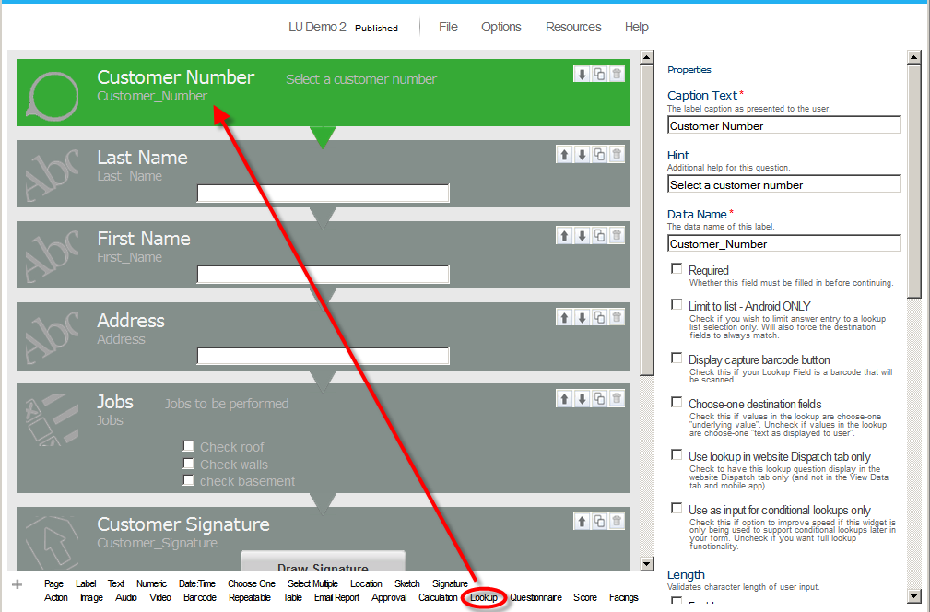

The Lookup question widgets include the following special properties:

Evaluate blank (null) condition values – [lookup] Causes lookup conditions to evaluate null (blank) condition values. Otherwise, null (blank) condition values will be ignored. Use this if one or more steps in a set of sequential lookup conditions need to be evaluated as being “null” rather than just skipped if left blank. . This option is important in optimizing the performance of the lookup widget when null values are a possibility.

Limit to list – Limits the entry of data to a lookup table selection only. If the lookup has any destination questions, the answers to these questions will also be limited to the corresponding values in the lookup table.

Sort lookup list alpha-numerically – [lookup] Check this if you want to sort your lookup field alpha-numerically. Numbers are sorted first, followed by letters. If you wish to avoid sorting results like 1, 2, 3 …..8, 9 then pad number values with leading zeros 01, 02, 03 … 08, 09, 10, 11.

Display the capture barcode button – If checked, the mobile app will include a Barcode scanning control in the question widget. This is handy if your “Lookup Field” is a barcode.

Choose-one destination fields – Check if you would like to compare the lookup table value with the “underlying_value” property for choose-one “destination questions”. Otherwise the lookup table value will be compared with the “Answer as displayed to the user” choose-one property of the choose-one “destination questions” When the values are the same, that answer option in the choose-one answer option will be selected.

For example, suppose your form has a choose-one question with the following answer options:

Answer as displayed to the user Underlying_value
YES 1
NO 0

In this case if your lookup table had YES/NO answers you would NOT check the “Choose One Destination Fields” option. But if your lookup table had 1/0 answers you WOULD check the “Choose One Destination Fields” option.

Use lookup in website Dispatch tab only – Use the display the lookup in the website Dispatch tab only. This property is used when you wish to use a lookup to pre-populate a dispatched record on the website prior to sending, but do not wish the send the lookup table to the mobile devices.

Use as input for conditional lookups only – Check this option to improve speed if this widget is only being used to support conditional lookups later in your form. Uncheck if you want full lookup functionality

Kind – Specifies the type of value used in the lookup field - Number or Text.

Data source – Selects the lookup table to be used. In the example below we are using the “Customer List” lookup table. Use the “Refresh” option if you have recently added a new lookup table as a Resource and do not see it in the list of available data sources.

Lookup field – Selects the field in the lookup table that will be used in the lookup search/list. In the example below we are using the “CustomerNumber” field in the lookup table.

Lookup conditions – Specifies if any prior lookup selection from the same lookup table will be used to filter the lookup field. For example, if you have lookup table with state and city columns, you could setup a lookup question to select the state, and a second lookup question to select the city. In the second lookup question you could make the lookup condition “State” so that only the cities in the selected state are displayed. Lookup conditions can also be specified as the answer values to a prior text, numeric or choose one question in the form. Use the “Add field” option to add a new condition.

Destination fields – Provides a “mapping” of any additional lookup table fields that will be used to populate other question fields in your form. In the example below, we are going to search on the lookup field “CustomerNumber”, then use the “NameLast” field in the lookup table to populate the “Last_Name” field in the form, the “NameFirst” field in the lookup table to populate the “First_Name” field in the form, and “Address” field in the lookup table to populate the “Address” field in the form. Use the “Add field” option to add a new destination field.

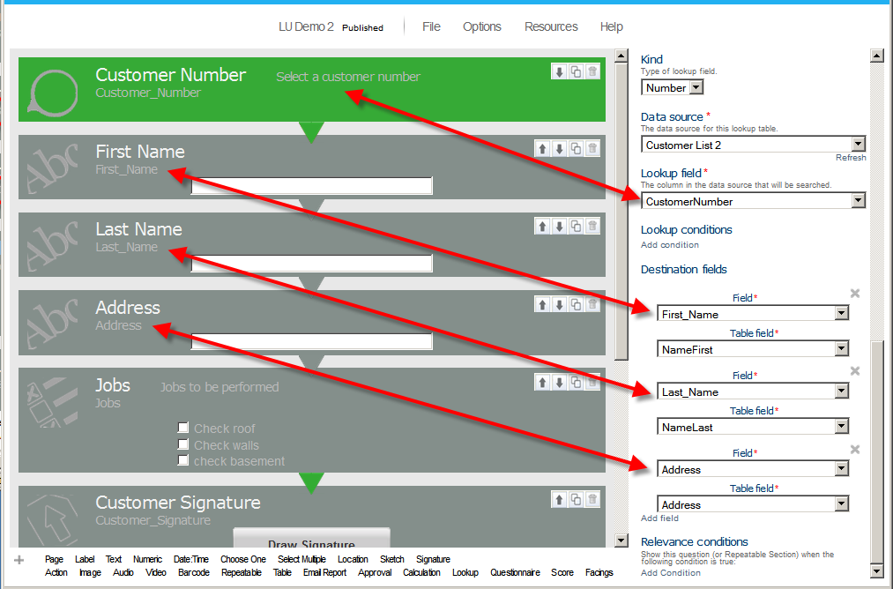

Using Tables (Paid Accounts Only)

http://www.doforms.com/support/how-to-videos/how-to-create-a-simple-invoice.htm

A table is a spreadsheet-like “container” for text, lookup, numeric, and calculation question types. Tables can have up to 10 columns. A fixed number of rows must be specified in the properties area. Tables are similar to Grids except that in a Table the contents of each row are repeated (the columns differ). Whereas, the contents of cells in a grid can be completely random.
.

To set up the table in your form, simply drag and drop the “Table” container widget into the desired location in the question canvas as illustrated below. Then drag and drop up to 10 text, lookup, numeric, and calculation questions into the table. Each of these questions will be a column in the Table.

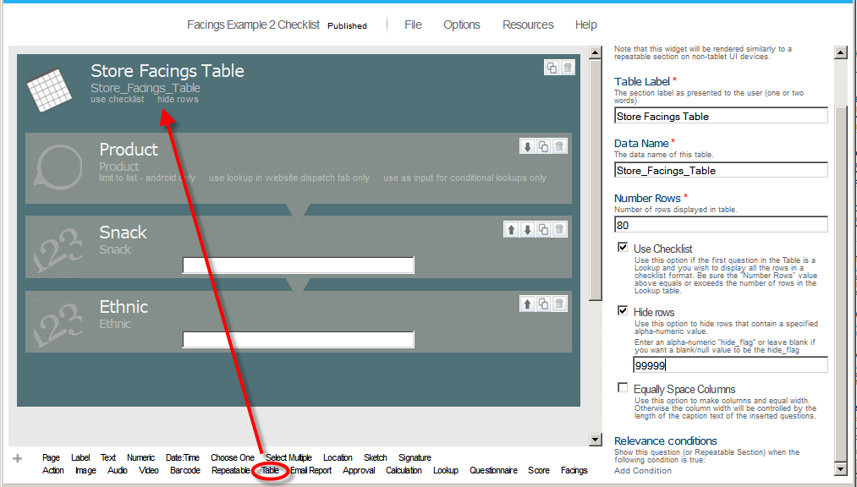

When rendered on the tablet mobile device in Form View, the table will look like this:

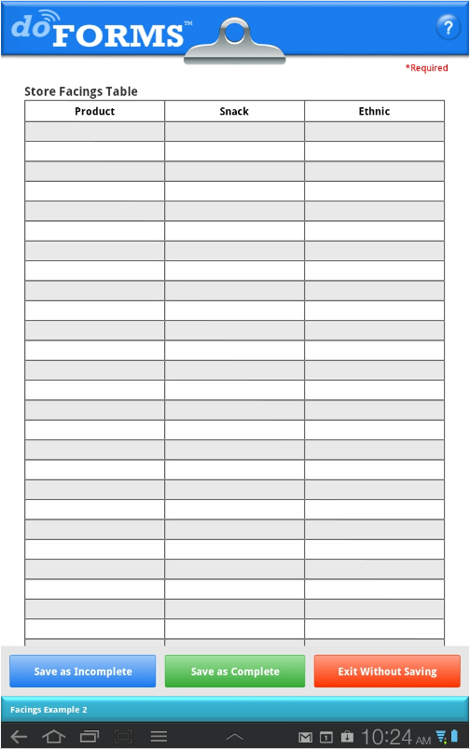

The Table container has several special properties:

Number rows – Specifies the number of rows in the table.

Use checklist – Use this option if the first question in the Table is a Lookup and you wish to display all the rows in a checklist format. Be sure the "Number Rows" value above equals or exceeds the number of rows in the Lookup table. See the following illustration of how the table above is rendered when the “Use checklist” option is selected.

Hide rows – This option is used in conjunction with the “Use Checklist” option. Use this option to hide rows that contain a specified alpha-numeric value. When checked an entry box will be displayed where you can enter an alpha-numeric “hide_flag” or leave blank if you want a blank/null value to be the hide_flag.

Column spacing – Specifies if columns will be evenly spaced (if checked) or variable width (if unchecked). The width of variable width columns will be determined by the length of their Caption Text property.

When rendered on the tablet mobile device in Form View, the “checklist” table will look like this:

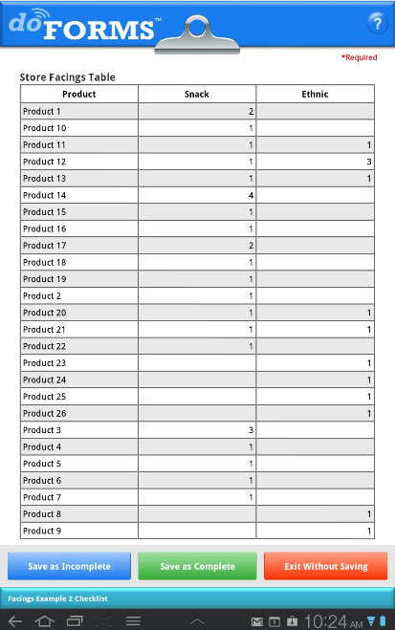

Using Grids (Paid Accounts Only)

A grid is a “container” for label, text, lookup, numeric and image question types. A fixed number of columns must be specified in the properties area. Grids are similar to Tables except that in a Table the contents of each row are repeated (the columns differ). Whereas, the contents of cells in a grid can be completely random.

To set up the grid in your form, simply drag and drop the “Grid” container widget into the desired location in the question canvas as illustrated below. Then drag and drop label, text, lookup, numeric and image questions into the Grid. Each of these questions will be a cell in the Grid. Questions placed inside the container are placed in the grid in a zig-zag pattern with each new line starting after the specified number of columns as illustrated below.

The Grid containers have several special properties:

Number columns – Specifies the number of columns in the Grid. This value will determine how many questions are placed in a row before a new row is started. For example, in the illustration below there are three columns. The first three questions are placed in the first row. The next three questions are placed in the second row, etc.

Column spacing – Specifies if columns will be evenly spaced (if checked) or of varying widths (if unchecked). In the illustration below the columns are equally spaced. The width of varying width columns will be determined by the length of the longest Caption Text property in any of the cells in that column.

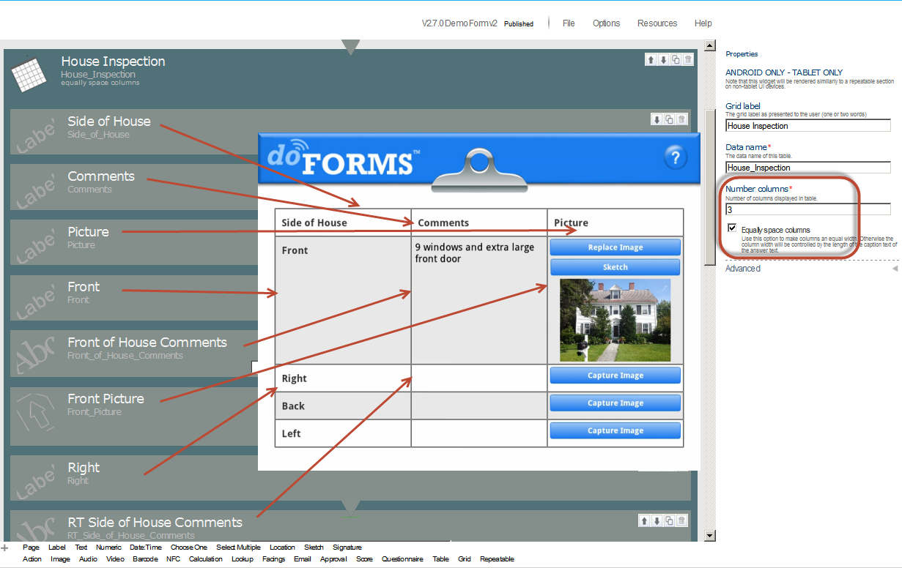

Emailing PDF and Excel Reports (Paid Accounts Only)

This feature allows you to email the completed form as a PDF or Excel report to one or more recipients in addition to sending it to your doForms website. The email is sent automatically when the completed form is sent and received by your doForms website. You can use the “Default” property to pre-populate email addresses. Use commas to separate multiple addresses.

In order to email a report from the doForms mobile app, you must insert an “Email Report” question widget into the form when building it. The position of the “Email Report” question widget in the form does not matter. The report will be sent at the same time the completed form is sent to your doForms website. To add an “Email Report” question widget into the form:

- Open the form in the Build Forms tab.
- Drag and drop the “Email Report” question widget into the desired location.
- Save your form when done.
To control the format of the PDF and Excel files, use the Options > Report Settings as described in the View Data section. If you change the report settings for a particular project/form in View Data, then those settings will also be applied whenever a report for this particular project/form is sent from the mobile app.

For more information see Creating PDF Reports and Creating Excel Reports in the View Data section of this guide.

Information Pages

You can create and insert an “Information” page anywhere in a form by using a Section Label question. Use the Caption text to provide a title or heading. Use the Hint property to provide additional information (e.g., instruction, warnings, etc.). In addition to textual information, these pages may contain images, logos and illustrations.

Previewing a Form

If you are building a complex form, we strongly recommend testing it on your mobile devices before deploying it to a large group of mobile users. The best way to do this is to set up a “Test Project” in the Projects tab and add your published form to this project. You will also need to remove it from the Main Project so that it is not deployed to your other mobile users. See the Projects section for how to do this. Then under the Mobile Units tab, assign the Test Project to just those mobile units that you wish to use for testing. See the Mobile Units section for how to do this.

Deploy Forms to Mobile Units

There are a number of ways to deploy your form to your mobile devices:

Publish to the Main Project - The simplest and fastest way is to go to the File menu and Save Form As > Published. This will save the form in a Published state and automatically add it to the Main Project. All of the mobile units that subscribe to the Main Project will automatically receive your form. Note that all mobile units are subscribed to the Main Project by default until you manually unsubscribe them in the Mobile Units tab.

Deploy Using the Projects tab – The other way to deploy your form is to use the Projects tab. This method provides you the greatest control over who gets which form. First, under the Build Forms tab go to the File menu and Save Form As > Published (if you haven’t done so already). Next, go to the Projects tab and manually select which projects the form is added to (see Projects section). Just those mobile units that subscribe to those selected projects will receive the form. This allows you to organize and deploy your forms by work-function; for example, if you created a “Field Inspection” form, you can add it to a “Field Project” which only your field workers are subscribed to. Use the Mobile Units tab to control which mobile units subscribe to which project.

In either case, your form will automatically be pushed out to all mobile devices that subscribe to the corresponding projects. This will occur the next time the mobile user starts the doForms mobile app, or when he or she uses the “Update Forms and Notices” function.

Updating Forms

If a form is Published and assigned to a Project (see above), future updates to that form can also be pushed out to the mobile devices that subscribe to that Project. For example, consider a case where you have a form named “Timesheet” that has been published. Later you decide to make changes to the Timesheet form and publish the updated form.

When you are done making changes, you will need to publish the updated Timesheet/Draft form. To publish the updated form go to the File menu and Save Form As > Draft or Save Form As > Published.

As described above, if you use File > Open, make edits to a form, then use Save Form As > Published, a new name will need to be assigned to the form. This is because every version of a form corresponds to a specific data table structure. So, for example, if you add or delete questions, or change a Repeatable Section, the underlying data table structure changes, and hence a new data table needs to be set up in which to store the data. Therefore when publishing an update to a form you will need to use a different name (we recommend appending a letter or number to the form name, e.g., Timesheet-2 or Timesheet-B).

However, there are instances where very “light edits” can be made to a form without affecting the data table structure. This may be done using the File > Open Special option , from where light edits may be performed, and from where you can File > Save with the same form name. In these cases the collected data will continue to be stored in the same data structure and same data table.

Public Forms Library

doForms provides a public Forms Library from which you can select forms that can be used directly in your projects. Or you can use these public forms as starting points for further customization to meet your specific requirements. To date, the Forms Library contains over 300 forms that have been contributed by users like you.

Using a Public Form

To access the Forms Library, go to the File menu and click Open. The open dialog will be displayed. At the bottom of this dialog, click on “Select a form from the doForms Public Library”. A second dialog box will open (see below). You can use this to enter the form name, if you know it. Or select keywords to describe what you are looking for. The more keywords you select, the more restrictive your search will be. You may also select a language to narrow your search. Click Search when done. A new dialog box will be displayed listing any public forms that meet your search criteria. Select a form from the list and press Open, otherwise press Cancel.

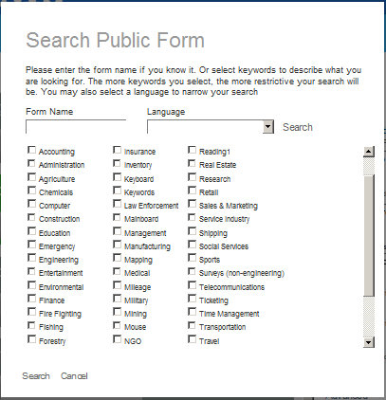

Contributing a Public Form

You may also contribute a form to the Public Forms Library. To do this, open the Published form that you wish to contribute in the Build Forms tab. Next, from the File menu select Make Form Public. A new dialog box will be displayed where you will be asked to enter descriptive information and select keywords that will help other users find the form. When done click Save, otherwise click Cancel.

Note that all forms submitted for inclusion in the Public Forms Library must first be reviewed and approved by the doForms editorial staff. They will reject your form if it contains content they deem inappropriate. They may reject your form if they feel it is too narrow in scope or purpose. Or they may decide to make some changes to your form.

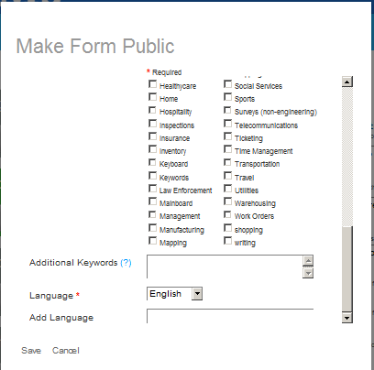

Projects

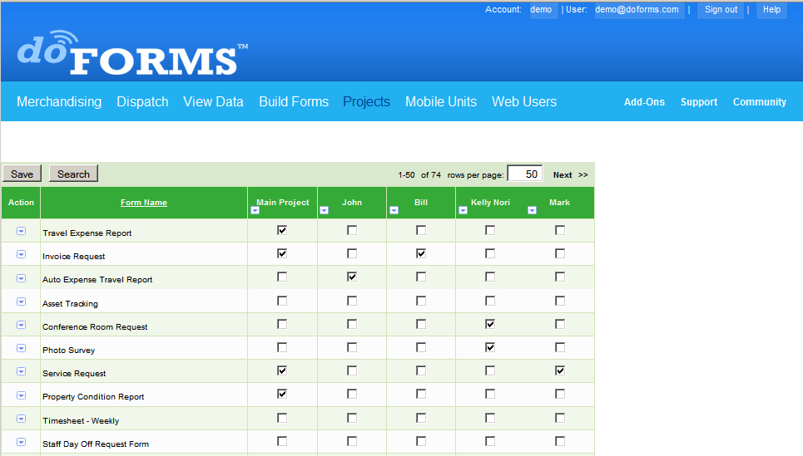

IMPORTANT: The Project tab is available to doForms users with Manage and Admin privileges only. Be sure to click Save at the bottom of the page to save any changes.

http://www.doforms.com/support/how-to-videos/how-to-manage-devices-and-projects.htm

Layout

The Projects tab is the place where you manage projects and forms. Your doForms database is organized by “Projects” which in turn contain the “Forms”. Note that the forms contain and organize the data, and any form may be listed under multiple projects (See Understanding Forms, Projects and Mobile Units).

The rows in the Projects tab represent the forms. The first column provides the form name (you can sort the table alphabetically by clicking this column heading). The remaining columns represent the projects, starting with the “Main Project”.

Main Project

Your doForms account starts out with one “Main Project” which provides you with useful forms. The Main Project is a little bit different than all other projects in that it is subscribed out to all mobile units. So if you create forms which you want to deploy to all mobile units, adding them to the Main Project in the Projects tab is an easy way to do so. Other projects that you create must be explicitly subscribed out to mobile units using the Mobile Units tab. Don’t worry, we will explain all this in the Mobile Units section. For now let’s learn more about the Projects tab.

Search

Displays a filter function that allows you to search for specific form names.

Column Menu

Let’s start with learning how to manage projects using the Column Menu. A close cousin of the Row Menu, it provides the following options :

Add project – To add a new project column, select Add project from the Column Menu. A new empty column will added. The new project will be titled “Project 1, 2, 3 etc”. You can change this name as described below.

Rename – To rename a project column, select Rename from the Column Menu. Type a new project name over the old one. Press Submit when done. Otherwise, press Cancel. Note that this function may not be applied to the Main Project.

Delete – To delete a project column, select Delete from the Column Menu. A message will be displayed asking you to confirm the delete. Click the OK button to permanently delete the project column. Otherwise, press Cancel. Note that this function may not be applied to the Main Project.

Select all forms – Use Select all forms from the Column Menu to select all forms for inclusion in the project column. If all the forms are selected, this Column Menu option changes to Deselect all forms which can be used accordingly.

IMPORTANT: Be sure to click Save to save any changes.

Row Menu

Next, let’s learn how to manage forms using the Row Menu. When you author a form in the Form Builder and “Save as … Published”, the published form resides in your doForms account. But it is not “deployed” until you add it to a project. At that point it is automatically deployed to the mobile units that subscribe to that project. We will show you how to assign projects to your mobile units in the next section. First, we need to show you how to add the form to a project.

Add form – To add a new form row, select Add form in the Row Menu. Then select a form from the list of Published forms in your account (see below). Then click Add form. Otherwise, press Cancel.

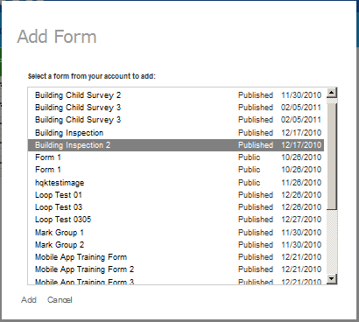

Remove – To remove a form, select Remove in the Row Menu. A message will be displayed asking you to confirm the remove. Click the OK. Otherwise, press Cancel. Note that removing a form from the Projects tab does not delete it from your doForms account. You can always add it back later (see the Build Forms section for instructions on how to permanently delete forms from your doForms account)

Select all projects – Use Select all projects in the Row Menu to include this form in all project columns. If all the projects are selected, this Row Menu option changes to Deselect all projects which can be used accordingly.

IMPORTANT: If a form is listed and the project is not checked AND if the data table contains data, then it will be listed in the View Data and Dispatch tabs. This will allow you to see/use the data on the website without mobile users seeing the form in the project. If a form is listed and the project is checked, then the form will always be listed in the View Data and Dispatch tabs – whether or not there is data in the table.

IMPORTANT: Be sure to click Save to save any changes.

Mobile Units

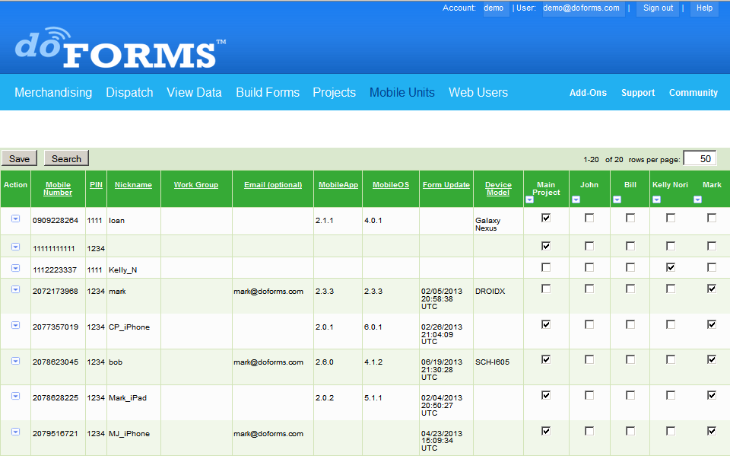

IMPORTANT: The Mobile Units tab is available to doForms users with Manage and Admin privileges only. Be sure to click Save at the bottom of the page to save any changes.

http://www.doforms.com/support/how-to-videos/how-to-manage-devices-and-projects.htm

Layout

The Mobile Units tab is the place where you manage which mobile units will be connected to your doForms account, as well as which projects (and their respective forms) will be available on which mobile units.

The rows in the Mobile tab represent each mobile unit. The number of rows displayed will match the number of mobile units supported by your account. Free doForms account supports just one mobile unit, so you will see just one row. A doForms-20 account supports twenty mobile units so you will see 20 rows. A doForms-100 account supports one-hundred mobile units so you will see 100 rows, etc. Your doForms Administrator can add rows for additional mobile units at any time by upgrading your current plan using the Account tab.

Mobile Number and PIN

The first and second columns provide the “Mobile Number” and “PIN”. Both MUST be entered into the Mobile Units tab in order for those mobile devices to be “connected” to you doForms website. Each time the doForms application is stated on a mobile device, it connects to the Internet and checks the information in the Mobile Units tab to see if it is still allowed to “connect” to your doForms website, and if so, which projects it needs to synchronize with. If it cannot find its Mobile Number and PIN in this list it will not connect to the website. So the information entered here must also be provided to the user of the corresponding mobile unit. They will be asked to enter this exact same Mobile Number and PIN when setting up doForms on their mobile unit.

IMPORTANT: The mobile numbers and PINs must match those entered into corresponding mobile devices.

Website Setup Wizard

When your doForms website starts for the first time, the Website Setup Wizard will appear. Website setup consists of two parts (i) telling the website which mobile devices are allowed to connect to it, and (ii) establishing login credentials for any website users other than you (see the Web Users section). If you use the Website Setup Wizard, the rows in the Mobile Units tab will be filled in through this process. But you can always change this information, or add mobile devices by following the steps below.

Search

Displays a filter function that allows you to search for specific mobile units.

Columns

Mobile Number – The mobile number will most likely be the 10-digit telephone number of the mobile device. If the device is a PC or tablet with no phone, the mobile number may be any 10-digit number.

PIN – The PIN can be any 4-digit number. We recommend using a different PIN for each mobile number. The number of mobile devices that you will be able to setup will correspond to your account level.

Nickname – Provides a “Nickname” for the mobile unit. You may use the mobile user’s name, or a company device ID, etc. Nicknames may be up to 20 characters. This is most useful when working in the Dispatch tab where it may be difficult to remember which mobile number corresponds to which mobile worker.

Work Group (optional) – Provides a way to classify your mobile units. The work group field is searchable with the Search button function.

Email (optional) – Provides an optional email address for the user of the mobile device.

MobileApp – Provides the version number of the mobile application installed on the corresponding mobile device. This will automatically be filled in when doForms is set up on the mobile device. You do not need to enter this information. The presence of this information will tell you that doForms has been successfully set up on the corresponding mobile device.

MobileOS – Provides the Operating System information of the corresponding mobile device. This will automatically be filled in when doForms is set up on the mobile device. You do not need to enter this information. The presence of this information will tell you what type of device this is and what its OS version is. This is very useful for technical support purposes.

Projects – See Projects section.

You can sort the table alphabetically by clicking on any of the underlined column headings. This is useful if, for example, you wish to see which mobile units use a particular MobileApp or MobileOS.

IMPORTANT: Be sure to click Save to save any changes.

Row Menu

The Row Menu provides the following functions:

Edit – To assign a Mobile Number, PIN and contact email to an available row, or to change an already assigned value, click Edit in the Row Menu. The row will expand allowing you to change certain fields. Click Change when done. Otherwise, press Cancel.

Delete – To delete a Mobile Number and PIN from a row, click Delete in the Row Menu. A message will be displayed asking you to confirm the delete. Click OK. Otherwise, press Cancel.

Send Email – Sends and email to the mobile user containing their Mobile Number and PIN settings.

Select all projects – Use Select all projects from the Row Menu to subscribe all projects to this mobile unit. If all the projects are selected, this Row Menu option changes to Deselect all projects which can be used accordingly.

Be sure to click Save at the bottom of the page to save any changes.

IMPORTANT: Note that when a new project is added, it will NOT be automatically assigned to any of the mobile units. You must explicitly do so either by clicking the checkboxes individually or by using the Column Menu to Select all mobiles. If all the projects are selected, this Column Action Menu option changes to Deselect all mobiles which can be used accordingly. Also remember that the “Main Project” is automatically added to all mobile units.

IMPORTANT: If a Mobile Number is deleted but the mobile device still has unsent forms, these forms will become “orphaned” on the device and will not be able to be sent to the website.

IMPORTANT: Be sure to click Save to save any changes.

Web Users

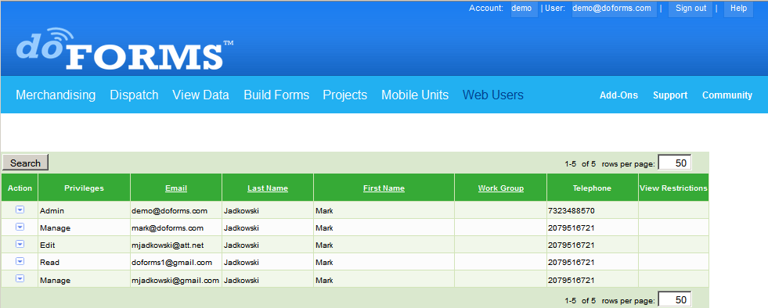

IMPORTANT: The Web Users tab is available to doForms users with Manage and Admin privileges only.

http://www.doforms.com/support/how-to-videos/how-to-manage-web-users.htm

Layout

The Web Users tab is the place where you manage who can access your doForms website and what privileges they will have. The rows represent the website users. The columns represent their privileges and attributes.

Website Setup Wizard

When your doForms website starts for the first time, the Website Setup Wizard will appear. Website setup consists of two parts: (i) telling the website which mobile devices are allowed to connect to it (see the Mobile Units section), and (ii) establishing login credentials for any website users other than you. If you use the Website Setup Wizard, the rows in the Web Users tab will be filled in through this process. But you can always change this information, or add web users by following the steps below.

Adding Users

When a new user requests access to your doForms website (see the Accessing the doForms Website section) their request will be displayed as a row marked as “Pending”. This request must be “accepted” by an existing web user with Manage and Admin privileges.

Accept – To accept a Pending request, click the Row Menu, and select one of the privilege levels under Accept. An email will automatically be sent to the user confirming that access has been granted. The privilege levels are as follows:

Read – Access to the “View Data Tab” to view data only.
Edit – Access to the “View Data Tab” to view, add, edit, delete, and export data.
Manage – Full access to all doForms website Tabs and all their functionality, including building forms, managing projects, connecting additional mobile devices, and setting up additional website users.

Deny – To deny a Pending request click Deny.

Changing User Information

Edit – Use to edit an existing Web User’s privileges, email (username), password or contact information. Click Edit in the Row Menu. The row will expand allowing you to change certain fields. Click Save when done. Otherwise, press Cancel.

Send Email – Use to send an email to the Web User after changing their account information. The email will contain the user’s new email (username), password and privilege level.

Delete – Use to delete a Web User. A message will be displayed asking you to confirm the delete. Click OK. Otherwise, press Cancel.

Add User – Use to a new Web User from the Web Users tab. A form will be displayed for you to enter the user’s information. Click Save when done. Otherwise, press Cancel.

Work Group (optional) – Provides a way to classify your web users. The work group field is searchable with the Search button function.

View Restrictions

You can control “who sees what” in the View Data tab by using the View Restriction parameter in the Web Users tab. This parameter allows you to restrict the viewing of records to those submitted by a specific device Mobile Number. For example, if you have multiple sales people accessing the View Data tab, you can specify that any particular salesperson can only view/edit the records which they submitted by specifying their Mobile Number as the View Restriction. You may specify multiple Mobile Numbers by separating them with spaces.

Search

Displays a filter function that allows you to search for specific mobile units.

Account

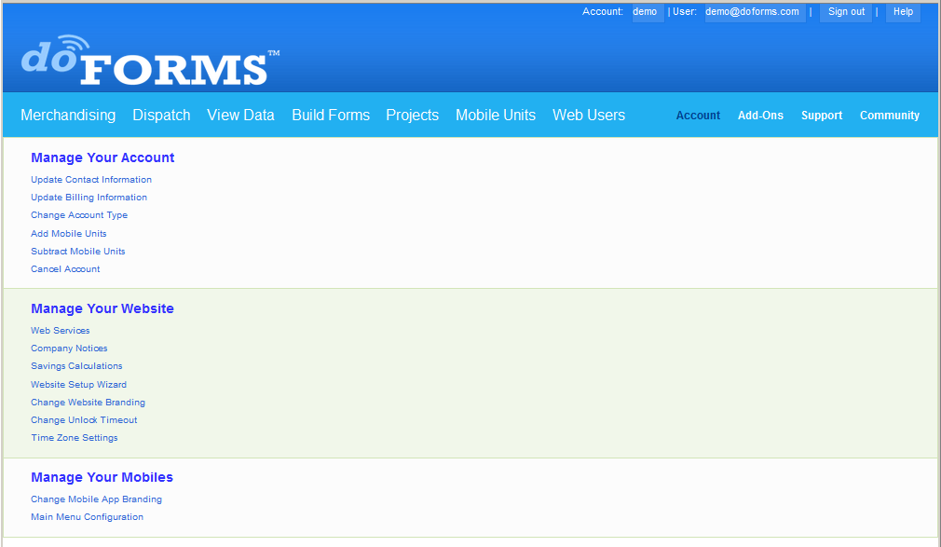

IMPORTANT: The Account tab is available to doForms users with Admin privileges only.

Manage Your Account

Update Contact Information – Use this to update the Administrator contact information for your doForms account. Note that these changes may take up to 72 hours.

Update Billing Information – Use this to update the credit card billing address information for your doForms account. Note that these changes may take up to 72 hours.

Upgrade Account (only visible in free account) – Use this to upgrade from a free Standard account to a paid Professional or Dispatch. Note that these changes may take up to 72 hours.

Change Account Type – Use this to change between Standard, Professional and Dispatch account types. Note that these changes may take up to 72 hours.

Add Mobile Units – Use this to increase the number of mobile units supported by your account. Note that these changes may take up to 72 hours.

Subtract Mobile Units – Use this to decrease the number of mobile units supported by your account. Note that these changes may take up to 72 hours.

Cancel Account – Use this to update cancel your doForms account. Please note that this can take up to 72 hours. You will receive a confirmation email when it is complete. Note that you will still be able to access your account at no-cost for 30 days after cancellation. Please be sure that you export any data that you wish to save within that time period. Your data will be deleted from our servers after 30 days. If you wish to cancel your cancellation, you may do so within this 30 day period by contacting us at support@doForms.com.

Manage Your Website

Web Services – The Web Services tab is the place where you manage web services which expose the data in your doForms account for use with other IT systems. doForms Web Services can be accessed using any program that supports SOAP web services. doForms web services are organized on a per-form basis. When a form is added to the Web Services tab, DoForms assigns a [WSID] and a [password] for accessing the form data. Please see the doForms Integration Guide for further information on using the Web Services. This guide can be found at: http://www.doforms.com/support/integration-guide.pdf

http://www.doforms.com/support/how-to-videos/how-to-create-company-notices.htm

Company Notices – Use this to create and publish text notices which will be visible to website users and users of mobile devices. These notices are very useful for pushing out important information or urgent warnings. The on/off control at the top determine if website or mobile notices are to be displayed. Be sure to click the Save button when making a change to the top section. To add a new notice, click the Add button beneath the existing notices. Type your notice. Designate if it’s to be displayed on the website and/or mobile units. Enter an Expiry Date. Be sure to click the Save button when done.

Savings Calculations – Use this FREE tool to calculate money savings and to calculate carbon savings by using mobile data forms instead of paper forms. The results of these calculations are displayed at the bottom of your doForms website for all your users to see. Use this option to fine-tune your dollar savings calculations by adjusting your labor costs, overhead percentages and other parameters. Refine the way you calculate CO2 savings by adjusting carbon lifecycle parameters. Methodologies vary, so please feel free to contact us and suggest additional ways by which to calculate carbon savings, that you would like to see us implement. Be sure to click the Save button when done. You may also reset the “form count” that the calculations are based on. Resetting the form count will set all the cumulative cash, CO2 and tree saving values to zero. The savings will then start accruing as new forms are received.

Website Setup Wizard – Use this to launch the Website Setup Wizard.

http://www.doforms.com/support/how-to-videos/how-to-manage-website-branding.htm

Change Website Branding – [paid accounts only] Use this to replace the doForms logo used in the website with one of your choosing. The logo image must be in JPG, PNG or GIF format. Size should be 320 px wide x 72 px tall. Use a transparent background or set the background color to Dark Blue - #1B79F1 (RGB= 27, 121, 241). Other colors used throughout the website are Light Blue - #22B0F1 (RGB= 34, 176, 241) and Light Green - #36AA36 (RGB= 54, 170, 54).

Change Unlock Timeout – [Dispatch accounts only] Use this to change the period of time after which form records in the View Data tab are unlocked by the Retrieve Function. Locked records will be automatically unlocked after the specified time so that other mobile users can retrieve them. Note that locked records are also unlocked whenever a mobile user sends the retrieved record back to the website.

Time Zone Settings – [paid accounts only] Use this to set the time zone for your doForms website. All time data will be displayed in the designated time zone to all users of the website. Use the “Daylight Savings Time” option to further control the time zone. Be sure to click the Save button after making a change. Note that these settings only affect the display and reporting of Date:Time information. The underlying data is always stored in UTC/GMT.

Manage Your Mobiles

Change Mobile App Branding – [paid accounts only] Use this to replace the word “doForms” with your own company name in the smartphone UI. Use this to replace the doForms logo used in the mobile app tablet UI with one of your choosing. The logo image must be in JPG, PNG or GIF format. Size should be 320 px wide x 72 px tall. Use a transparent background or set the background color to Dark Blue - #1B79F1 (RGB= 27, 121, 241). Other colors used throughout the website are Light Blue - #22B0F1 (RGB= 34, 176, 241) and Light Green - #36AA36 (RGB= 54, 170, 54). Be sure to click the Save button after making a change.

Main Menu Configuration – [paid accounts only] Provides option that controls whether the Dispatch and/or Retrieve menu buttons are displayed in the app Main Menu. You can use this to simplify this menu for all your mobile users if one or both of these functions are not used. Be sure to click the Save button after making a change.

Device Settings – [paid accounts only] Provides the ability to control your users’ doForms mobile app settings remotely. See next page for full list of remotely controllable settings. Note that each section provides an option to prevent mobile users from changing the corresponding settings on their mobile device. Be sure to click the Save button after making a change.

Mobile Device Settings:

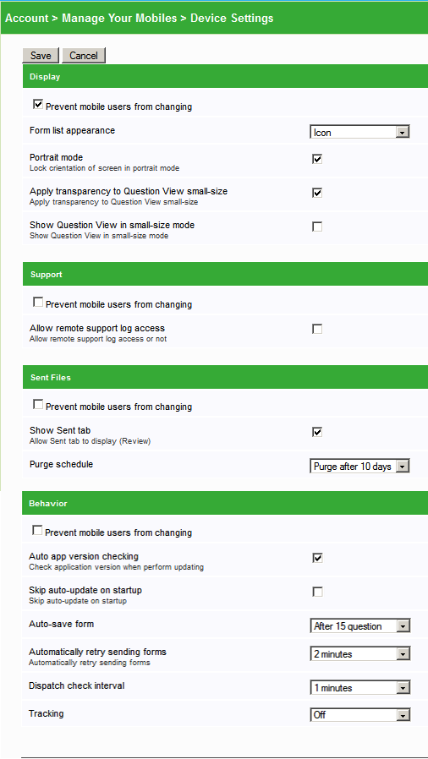

Contact doForms Support

Email: support@doforms.com
Website: www.doforms.com/support

Custom Development Services

Need programming services to help you with integrate doForms with an existing IT system?

Our software developers are experts at smartphone application development and related backends. If you have used doForms, you know how good their applications are.. Now this expertise is at your disposal for developing customized mobile business applications for your organization's specific needs.

Contact us for a free consultation

